Introduction to John’s Gospel

THE WORD BECAME FLESH

Key Verse: 1:14

“The Word became flesh and made his dwelling among us. We have seen his glory, the glory of the one and only Son, who came from the Father, full of grace and truth.”

Author
This gospel was written by John, the son of Zebedee. Since Zebedee could afford to hire workers, he must have been a prosperous businessman (Mk 1:20). John served his father in the fishing business in Galilee, together with his brother James (Mk 1:19). John was known to people of influence, such as the Jewish high priest (Jn 18:15-16). Jesus called John to be his disciple, along with James, and they became key members together with Peter in Jesus’ leadership development program. Jesus included these three men alone as witnesses of some key events in his ministry: raising Jairus’ daughter (Mk 5:37), his transfiguration (Mk 9:2), and during his prayer at Gethsemane (Mk 14:33). Jesus gave John and James the nickname “Boanerges,” which means “sons of thunder” (Mk 3:17). Once, when people of a Samaritan village did not accept Jesus, John wanted to call fire down from heaven to destroy them (Lk 9:54). Apparently, he was a passionate and hot-tempered man. When he heard that the stone had been rolled away from Jesus’ tomb, he outran Peter to get there first. However, he was too cautious to go inside. He seems to have been ambitious and competitive. When Jesus was just about to enter Jerusalem to die on the cross, James and John, by the help of their mother, asked Jesus for the places at his right and left in his kingdom (Mt 20:20; Mk 10:35). Because Jesus is God who is holy and just, we cannot say that he showed favoritism toward his disciples. However, John felt that he received the love of Jesus most. So he referred to himself as “the disciple whom Jesus loved” (13:23; 19:26; 20:2; 21:7,20). He was confident enough in Jesus’ love to lean back against him at the Last Supper and ask who would betray Jesus (Jn 13:25). He was also the first one to recognize the Risen Jesus when he visited them by the shore of the Sea of Galilee (Jn 21:7). As Jesus hung on the cross, John was there, uniquely, among the disciples. At that time, Jesus entrusted his mother to John. According to tradition, John cared for her to the end at Ephesus. John was an eye witness that Jesus is God in the flesh (Jn 1:14; 1Jn 1:1-3). He fought against the false teaching of Gnosticism, which denied that Jesus Christ came in the flesh. He grasped the core teaching of Jesus that God is love (1Jn 4:8) and he testified that “God so loved the world” (Jn 3:16). He bore witness to Jesus’ new command, “Love one another” (Jn 13:34), and exhorted Christians, “Let us love one another” (1 Jn 4:7).

Date and Place of Writing
The most likely date of this gospel is A.D. 90-100. It was written at Ephesus in Asia Minor (modern day Turkey), an important urban center in the Roman Empire at that time, and the site of the Ephesian church which was very influential in early Christian history.

Audience
Three gospels: Matthew, Mark and Luke were written about 30 years after Jesus’ death and resurrection. They were circulated widely and spread all over the Roman world. John’s gospel was written much later. Why might he have thought his gospel was necessary? He had seen the rise of many false teachings, especially those of Gnosticism, which tried to undermine Jesus’ identity as fully human and fully God. John must have felt that he needed to witness that Jesus is God in the flesh by testifying to what he had heard, seen, looked at and touched (1 Jn 1:1).

Living in Ephesus, John had seen the profound impact the gospel had on the whole world. It seems that his original audience consisted of both Jews and Gentiles living in the larger Greco-Roman world and beyond. John’s gospel is universal. For this reason, John explains Jewish customs, translates Aramaic terms into Greek, and refers to geographic areas in a more universal way (1:38,41,42; 4:9,25; 5:7; 11:16; 19:17,20; 20:16,24; 21:1).

Literary Form
John’s gospel, like all of the other gospels, is written in narrative prose. However, John is quite distinct from the other gospels. Matthew, Mark and Luke are called “synoptic” gospels because they have the same view of Jesus. Matthew saw Jesus as King, Mark saw Jesus as a servant, Luke saw Jesus as an historical man. They all saw Jesus as a human being, and after having carefully investigated everything about Jesus, reached the conclusion that Jesus is the Son of God. However, John’s view of Jesus was different. John saw Jesus as God incarnate. So he started his gospel with the basic premise that Jesus is God and then explains this major premise. So John’s gospel is called a special gospel.

Main Theme
The main theme of John’s gospel is that Jesus is the Son of God and the promised Messiah. John supports this theme by presenting testimonies and Jesus’ own declarations about his identity. The testimonies come from John the Baptist (1:7,8,15,19-28,34; 3:26-36; 5:33-35), Jesus’ disciples and many others who met Jesus personally (1:29,36,41,49; 4:29,39,42; 6:14; 7:68; 9:38; 11:27; 12:17; 15:27; 16:30; 20:28), the author John (19:35; 21:24), the Father God (5:32,37; 8:18), Jesus himself (8:13,14; 18:37), the works of Jesus (5:36; 10:25; 14:11; and his seven miracles), the Holy Spirit (15:26; 16:13,14), and the Scriptures (5:39; 13:18-19; 20:9). Furthermore, Jesus declared about himself: “I am he” (4:26; 8:24,28), “I am the bread of life” (6:35,41,48,55), “I am the light of the world” (8:12; 9:5), “I am the gate” (10:7,9), “I am the good shepherd” (10:7,11,14), “I am the resurrection and the life” (11:25-26), “I am the way and the truth and the life” (14:6), and “I am the true vine” (15:1,5).

This Jesus, who is God, came into this world as a human being. We call him God Incarnate, who “made his dwelling among us” (1:14). The word “dwelling” also means “tabernacled.” The tabernacle in the Old Testament was where the holy God dwelled among his people, so that they could hear his voice, and have fellowship with him. In Jesus, God lived among us in a very real and practical way. Jesus called disciples to know him personally and share life together (1:35-51). Jesus attended a wedding of ordinary people at Cana in Galilee and blessed it (2:1-11). Jesus talked with Nicodemus, a Pharisee, who was bound by Jewish tradition and legalism, and opened the way for him to enter the kingdom of God (3:1-21). Jesus humbled himself to engage in conversation with a Samaritan woman, who was most despised and outcast and gave her living water welling up to eternal life (4:1-26). When Jesus went to Jerusalem to attend a Jewish festival, he visited the Pool of Siloam where the most fatalistic, lonely and isolated people gathered. There he healed the most hopeless among them (5:1-15). The events of chapters 7-10, nearly four chapters in the middle of John’s gospel, take place in Jerusalem during the Feast of Tabernacles. Jesus gave some of his most significant teachings at that time, literally fulfilling the meaning of the tabernacle.

Purpose of John’s Gospel
John clearly states the purpose of his gospel in 20:31 as follows: “But these are written that you may believe that Jesus is the Messiah, the Son of God, and that by believing you may have life in his name.”

Characteristics
Dialogue: John includes many extended dialogues with people: Nicodemus (ch. 3), the Samaritan woman (ch. 4), the Jews (ch. 5,10), the crowd (ch. 6), a man born blind (ch. 9), Mary and Martha (ch. 11), his disciples (ch. 13-16), Mary Magdalene and Thomas (ch. 20). Through these conversations Jesus reveals that he is the Messiah sent by God.

The Word: Jesus is the Word (1:1). The Word became flesh (1:14). Jesus teaches the word (17:7). Jesus’ word is the word of truth (17:17). The word is spirit and life (6:63). How people respond to the word is a matter of life and death (5:24). The disciples believe the word and the word sets them free and cleanses them (8:31-32; 15:3). The religious leaders do not accept the word and remain in their sins (8:24,37). Jesus’ word is not just the word of a human being; it is the word of the Son of God which has life and power to judge (5:24,27; 12:48). Jesus urged his disciples to remain in his words (15:7).

The world: John used the word “world” 74 times in his gospel (1:9,10,10, 10,29; 3:16,17,17,17,19; 4:42; 6:14,32,51; 7:4,7; 8:12,23,23,26; 9:5,5, 31; 10:36; 11:27; 12:19,25, 31,31,46,47,47; 13:1,1; 14:17,19,22,27,30,31;15:18,19,19,19,19;16:8,11,20,21,28,28,33,33;17:5,6,9,11,11,13,14,14,14,15,16,18,18,21,23,24,25; 18:20, 36,37; 21:25). Though God made the world through Jesus originally, the world was estranged from its Creator due to people’s sins. The world had come under the power of the “prince of this world” (12:31; 14:30; 16:11; Satan). However, God so loved the world that he sent his one and only Son Jesus into the world to save mankind from sin and Satan’s rule.

Sign: John used the word “sign” rather than miracle. He wants us to see the meaning of Jesus’ miracles, and not just the miracles themselves. John’s gospel has only 7 recorded miracles, while other gospels have many more. John emphasizes faith based on Jesus’ word rather than on miracles (2:23-24; 4:48-50).

Jesus’ time and hour: Jesus lived and worked according to God’s time schedule, not at random or based on people’s requests (2:4; 7:6,8,30; 8:20; 9:4; 12:27; 13:1; 14:29; 16:2,4,21,25; 17:1; 21:22). God had a plan for Jesus and Jesus obeyed God’s sovereign will.

Confession: Jesus’ disciples confessed their faith in Jesus from the very beginning (1:41,4549). A Samaritan and the people of her village confessed that Jesus is the Savior of the world (4:29,42). Peter confessed that Jesus is the holy one of God who has the words of eternal life (6:68-69). A man born blind confessed his faith in Jesus as the Messiah and worshiped him (9:38). Martha confessed that Jesus is the Messiah, the Son of God, who is to come into the world (11:27). The book climaxes with the confession of Thomas to Jesus, “My Lord and my God! (20:28).

Communion: John does not include communion at the Last Supper, as the synoptic gospels do. Instead, John explains the meaning of manna, which is the true bread from heaven—that is, Jesus himself—as Jesus declared that he is the bread of life (6:35). Jesus’ body is real food and his blood is real drink that we should eat and drink to have eternal life (6:53-56).

Glory: The words “glory,” “glorify,” and “glorified” are repeated 37 times (1:14,14; 2:11; 5:41; 5:44,44; 7:18,18,39; 8:50,54,54,54; 9:24; 11:4,40; 12:16,23,28,28,41; 13:31,32,32,32; 14:13; 15:8; 16:14; 17:1,1,4,5,5,10,22,24,24). The word “glory” means “to reveal God’s divine nature.” Jesus revealed God through his life, words and works. Finally, Jesus revealed God fully through his death on the cross and resurrection.

The work of the Holy Spirit: The Holy Spirit revealed to John that Jesus was the Messiah (1:32-34). Jesus explained that the Holy Spirit gives new birth (3:5-8). The Holy Spirit dwells in believers’ hearts to quench their thirst and becomes rivers of living water flowing from within them (7:37-38). When Jesus told his disciples he was leaving this world, he promised not to leave them as orphans but to be with them forever by sending the Holy Spirit (14:17-18). The Holy Spirit is the Spirit of truth (14:17; 16:13). The Holy Spirit reminds the disciples of everything that Jesus said to them (14:26), and guides them into all the truth (16:13). The Holy Spirit testifies about Jesus (15:26) and helps the disciples to testify as well, even in the midst of persecution (15:27). The Holy Spirit convicts the world about sin, righteousness and judgment (16:8-11). The Holy Spirit glorifies Jesus (16:14). After his resurrection, Jesus said to his disciples, “Receive the Holy Spirit” (20:22). Here, the Holy Spirit is related to preaching the gospel of forgiveness of sins (20:23).

Jesus teaches during Jewish festivals: In John’s gospel Jesus often teaches during festivals in Jerusalem. These festivals were very meaningful because all of them pointed to the Messiah. In chapter 2, Jesus cleansed the temple during the Passover. Then he taught them that he is the temple. In chapter 5, Jesus attended a Jewish festival in Jerusalem. He healed a paralytic man on the Sabbath, and then taught that he has authority to give life and to judge. In chapters 7-10, while at the Feast of Tabernacles, Jesus proclaimed that he is the Messiah by declaring that he is the living water, the light of the world, the good shepherd, and the gate, and by healing a man born blind. In the last part of chapter 10, Jesus is at the Feast of Dedication, and the events in chapters 12-20 take place during the Passover. In this way Jesus revealed himself as the Messiah so that they may believe in Jesus and have life in his name (20:31).

Jesus’ Gethsemane prayer: Unlike the synoptic gospels, John does not include Jesus’ prayer at Gethsemane. But we can find Jesus’ agony before taking the cross (12:27-28a).

Kernel of wheat: Jesus explained the meaning of his death in a unique manner by comparing himself to a kernel of wheat that falls to the ground and dies and produces many seeds (12:24).

Jesus’ words on the cross: Jesus words from the cross mentioned by John are unique. Jesus said, “Woman, here is your son,” and “Here is your mother” (19:26-27). Jesus said, “I am thirsty” (28). And he spoke his final word, “It is finished” (19:30).

“I am sending you”: John’s gospel includes the world mission command in a unique way. In his high priestly prayer, Jesus said: “As you sent me into the world, I have sent them into the world” (17:18). After his resurrection, Jesus told his disciples, “As the Father has sent me, I am sending you” (20:21). As the Father sent Jesus into the world to save people from their sins and death, so Jesus sends his disciples to the world with the gospel of forgiveness of sins.

Contrasts: There are many contrasts in John’s gospel.

Light and darkness (1:4,5,5,5; 3:19;19;19,20;20,21; 5:35,35; 8:12,12,12; 9:5; 11:9,10; 12:35, 35,35,36,36,36,46,46).

Life [or live] and death [or die] (1:4,4; 3:15,16,21,36,36; 4:14,36,47,49,50,53; 5:21,21,24,24, 24,25,26,26,29,39,40; 6:27,33,35,30,47,48,49,50,51,51,53,54,54,57,57, 58,58,63,63,68; 7:35,42; 8:11,12,21,24,24,51,52,52,53; 10:10,11,15,17,28; 11:4,13,16, 21,25,25,25,26,26, 32,50,51,53; 12:1,24,24,25,25,25,33,33,50; 13:37,38; 14:6,17,19,19; 15:13; 17:2,3; 18:14, 32,32; 19:7; 20:31; 21:19,23,23).

Love and hatred [or hate] (3:16,20,19; 5:42; 7:7,7; 8:42; 11:3,5,36; 12:25,43; 13:1,1,23,34,34,34,35; 14:15,21,21,23,24,28,31;15:9,9,9,10,10,12,12, 13,17,18,18,19,19,23, 24,25; 16:27; 17:14,23,23,24,26; 19:26; 20:2; 21:7,15,15,16,16,17,17, 17,20).

Belief [or believe] and unbelief [not believe] (1:7,12,50; 2:11,22,23; 3:12,12,15,16, 18,18,18,36; 4:21,39,41,42,48,48,53; 5:24,38,44,46,46,47,47; 6:29,30,35,36,40,47,64,64,69; 7:5,31, 38,39,48; 8:24,30,31,45,46; 9:18,35,36,38; 10:25,26,37,38,38,42; 11:15,25,26,26,26,27,40, 42,45, 48; 12:11,36,37,38,39,42,44,44,46; 13:19; 14:1,1,10,11,12,29; 16:9,27,30,31; 17:8,20,21; 19:35; 20:8,25,27,29,29,31,31; 21:23).

Salvation [or save] judgment [or judge] (3:17; 5:22,22,24,27,30,30,34; 7:24; 8:15,15,16, 26,50; 9:39; 10:9; 12:31,47, 47,47,48; 16:8,11)

Truth [or true] and lies [or liar or false] (1:9,14,17; 3:21,33; 4:18,23,24,37; 5:31,32, 33; 7:18, 28; 8:16,17,32,32,40,44,44,44,44,45,46,55; 7:18; 9:24; 10:41; 14:6,17; 15:1,26; 16:13,13; 17:3,17, 17; 18:23,37,37,38; 19:35,35; 21:24)

Purpose of Our Study

The purpose of John’s gospel is to help people believe that Jesus is the Messiah, the Son of God, and to have life in his name. Believing in Jesus is to have a relationship with him based on his words. There are many people who say they believe in Jesus, but their faith is not based on Jesus’ words. Rather, it is based on miracles or mystical experiences. Jesus does not trust such people. Those who have no root in Jesus’ words will leave him when their expectations are not met. Only those who have the word of Jesus in their hearts take root in him and grow and bear fruit. This is why we need faith based on Jesus’ words.

Another tendency is that people focus on religious activities rather than having a personal relationship with Jesus. Even Bible study may seem like a religious activity that does not connect them to Jesus (5:39-40). The purpose of Bible study is to have a relationship with Jesus. Jesus invites us to come and have fellowship with him. He offers himself as real food and real drink that we should eat and drink every day to have life. He wants us to hold on to his word continually so that we may have true freedom from sin and death. He wants to have a vine and branch relationship with us so that we may bear fruit. He wants us to have a deep love relationship with him, and on this basis to feed his sheep.

Page Break
Diagrams

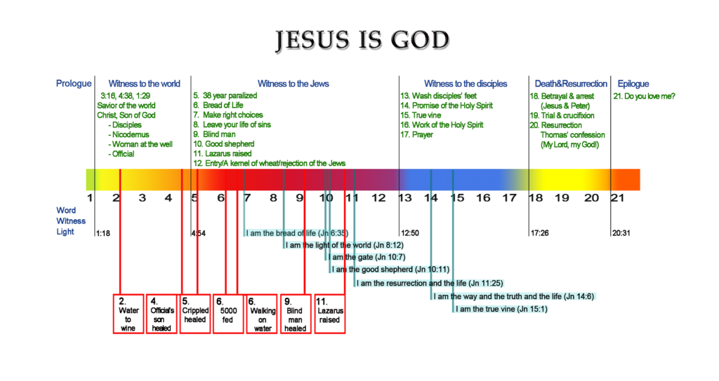

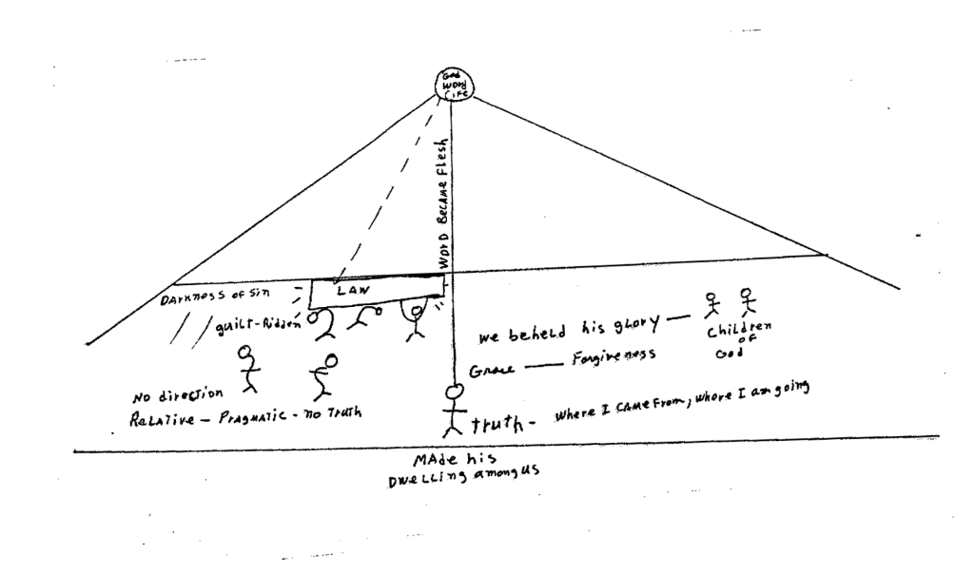

(These diagrams have been used courtesy of Mother Sarah Barry, the original author.)
Outline

I. Prologue: the Word became flesh (1:1-18)

a. Jesus is the eternal, Creator God (1:1-3)
b. Jesus is the source of life (1:4-5)
c. Jesus is the true light (1:6-9)
d. The way of becoming children of God (1:10-13)
e. Jesus is full of grace and truth (1:14-18)

II. Jesus presents signs and declarations that he is the Messiah (1:19-12:50)

1. Witness to the world (1:19-4:54)
a. The witness of John the Baptist (1:19-34)
b. The testimonies of Jesus’ first disciples (1:35-51)
c. Jesus’ first sign: changing water into wine (2:1-12)
d. Jesus cleared the temple (2:13-25)
e. Jesus taught Nicodemus: “You must be born again” (3:1-15)
f. Jesus said: “God so loved the world…” (3:16-21)
g. John testified that Jesus is the Messiah (3:22-36)
h. Jesus invited a Samaritan woman to drink living water (4:1-15)
i. Jesus revealed himself as the Messiah to a true worshiper (4:16-26)
j. Jesus urged his disciples to open their eyes and see the harvest (4:27-38)
k. Samaritans testified that Jesus is the Savior of the world (4:39-42)
l. Jesus’ second sign: healing an official’s son (4:43-54)

2. Witness to the Jews (5:1-12:50)
a. Jesus’ third sign: healing a 38-year invalid (5:1-15)
b. Jesus taught his authority to give life and to judge (5:16-30)
c . Jesus offered testimonies: John, his works, his Father, Scripture (5:31-47)
d. Jesus’ fourth sign: feeding 5,000 with five loaves and two fish (6:1-15)
e. Jesus’ fifth sign: walking on water (6:16-24)
f. Jesus’ first declaration: “I am the bread of life” (6:25-59)
g. Simon Peter confessed that Jesus has the word of eternal life (6:60-71)
h. Jesus invited thirsty people to drink living water at the Feast of Tabernacles (7:1-53)
i. Jesus rescued an adulterous woman (8:1-11)
j. Jesus’ second declaration: “I am the light of the world” (8:12-20)
k. Jesus taught: the truth will set you free (8:21-59)
l. Jesus’ sixth sign: healing a man born blind (9:1-41)
m. Jesus’ third/fourth declarations: “I am the gate,” “I am the good shepherd” (10:1-21)
n. Jesus testified that he and the Father are one (10:22-42)
o. Jesus’ fifth declaration: “I am the resurrection and the life” (11:1-27)
p. Jesus’ seventh sign: raising Lazarus from the dead (11:28-57)
q. Jesus accepted Mary’s anointing for his burial (12:1-11)
r. Jesus entered Jerusalem as a king (12:12-19)
s. Jesus prophesied his death as a kernel of wheat (12:20-36)
t. The Jews’ unbelief fulfilled prophecy (12:37-43)
u. Jesus invited unbelieving people to his light (12:44-50)

III. Jesus’ Upper Room Discourse and High Priestly Prayer (13:1-17:26)

a. Jesus washed his disciples’ feet and gave them a new command (13:1-38)
b. Jesus’ sixth declaration: “I am the way and the truth and the life” (14:1-14)
c. Jesus promised the Holy Spirit (14:15-31)
d. Jesus’ seventh declaration: “I am the true vine” (15:1-17)
e. Jesus explained why the world hates him and his people (15:18-25)
f. Jesus taught the work of the Holy Spirit (15:26-16:15)
g. Jesus taught that he came from the Father and goes back to the Father (16:16-33)
h. Jesus’ high priestly prayer for himself, for his disciples, for all believers (17:1-26)

IV. Jesus’ trials, suffering, death and resurrection (18:1-20:31)

a. Jesus was arrested and tried before the high priest and Pilate (18:1-40)
b. Jesus was crucified and died (19:1-30)
c. Jesus was buried (19:31-42)
d. Jesus rose again and appeared to Mary, his disciples and Thomas (20:1-29)
e. The purpose of John’s gospel (20:30-31)

V. Epilogue—the Risen Jesus reinstated Peter (21:1-25)

