INCARNATIONAL MINISTRY ACROSS CULTURES
Mark Yang, Moses Noh, Steve Stasinos

“Therefore go and make disciples of all nations, baptizing them in the name of the Father and of the Son and of the Holy Spirit, and teaching them to obey everything I have commanded you. And surely, I am with you always, to the very end of the age.” (Mt 28:19-20)

Objective

To understand and grow in being incarnational like Jesus by learning how to contextualize and communicate the gospel cross culturally in order to make disciples of all nations effectively.

Introduction

Make Disciples of All Nations – Jesus Commands Cross-Cultural Ministry

- The gospel is for all nations. Jesus commands us to go and make disciples of all nations. We believers are called to be witnesses of the gospel of Jesus Christ to the people of the world. We are to summon the nations that we do not know (Isa 55:5).

- When the gospel is preached, people believe in Jesus as their Savior and Lord. We baptize them in the name of the Father and of the Son and of the Holy Spirit as their public confession of faith in Jesus. After that we are to teach them to obey all that Jesus has commanded us.

- As we go and share the good news of the gospel to the people of all cultures of the earth, we face barriers, such as language and cultural differences, which need to be understood and overcome to help individual people become Jesus’ disciples. Understanding native culture is essential to effective communication of the gospel, teaching obedience, and working together to make more disciples.

Cultures and Gospel Truth

- Different countries have different cultures. Culture expresses people’s living habits, rules of conduct, beliefs, values and identity. Every human being is born into a culture, and adopts that culture to some degree subconsciously, as a fish adapts and grows in the surrounding water. If the water is changed, the fish will suffer and likely die. It is therefore important to acknowledge the influence of culture on individuals we are ministering to, as well as our own cultural influences.

- When we enter another nation, we bring our own culture with us. There is a tendency to side with our own culture as superior to the native culture, and to condemn the native culture and justify our own. This is called cultural imperialism and it often hinders gospel ministry. Our primary task as gospel workers is to teach how to apply and live by gospel truth, not to change native culture to be compatible with our own.

- In addition to our native culture, we may also have a ministry culture. Since we accepted the gospel and learned to live it out in a community, a subculture is formed with its own values. Such ministry culture and traditions usually have good intentions but if they are overly emphasized it can hinder the gospel ministry (e.g. conflicts between Jewish Christians and Gentile Christians in the early Christian church).

- Culture is relative and changeable but the gospel truth is absolute and unchangeable. Being truth, the gospel truth is something that does not change subjectively, but is absolute for each person in every generation and culture. The core gospel truth is that we are saved only when we believe in Jesus who died for our sins and who rose again from the dead. We are justified by God’s grace through faith in Jesus, not by our own righteousness through work and good deeds. Through faith in this gospel, we enter into a right relationship with God. This gospel truth cannot be amended by any cultural custom (Ga 2:14-16).

- In view of our new relationship with God as his children, the truth of the gospel leads us to a holy life (1Pe 1:14-16). The gospel transforms us regardless of our cultural background. The gospel gives a spiritual desire to live a holy life according to the word of God (1Thess 4:3-7). The gospel converts our value system and reshapes the meaning and purpose of life. Through the gospel, earthly hopes that perish, spoil and fade are being replaced by a living hope (1Pe 1:3-4). This living hope of future glory in heaven enables us to endure all kinds of hardships, to purify our motives, and grow in the image of Christ. National and religious identity fuels conflict through pride. But gospel truth replaces this with a new identity as citizens of heaven, based on this living hope (Php 3:20-21).

- The gospel truth is timeless and absolute in its application and relevance. Yet all of us live out this gospel truth in the context of a culture. Each culture has its unique mores, values, methods, and rituals that instruct and guide people how to live, act, worship, pray, etc. These may enhance or hinder the gospel truth’s practical application. Naturally then there can be a tension developed between gospel truth and culture. The bottom line is that cultural matters must be considered as secondary to gospel truth, and conformity to it and its application is to be done in a flexible and graceful way.

Effective Communication through Understanding Native Culture

- In order to communicate the gospel effectively, understanding native culture is essential. David Hesselgrave says in his book Communicating Christ Cross-Culturally that the cultural barrier is the greatest barrier in preaching Christ to native people in different cultures. Effective communication with native people depends on how much Christians understand the native culture.

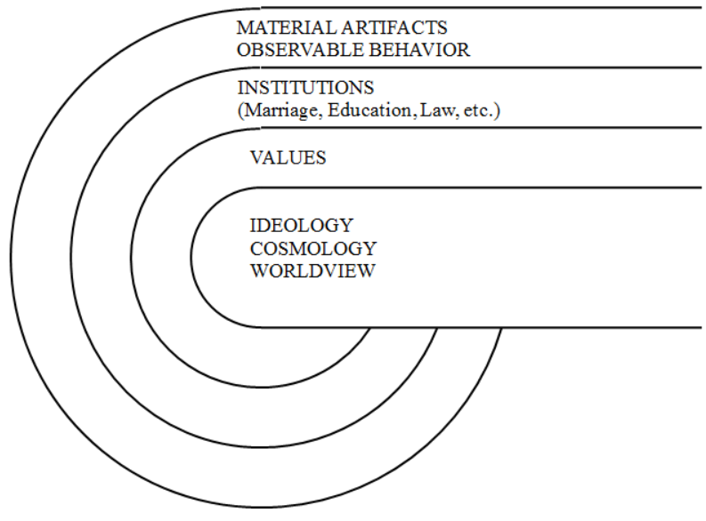
- G. Linwood Barney described that our cultures consist of multiple layers (Figure 1). Cultural influence flows from the deep parts of worldview and values, which create, maintain and shape institutions (marriage, education, law, etc), material artifacts and observable behavior. When encountering a native culture, the first two outer layers are easily observed and understood to a degree, but this is only a shallow understanding. We need to go from a shallow understanding of the culture to know the deeper elements of worldview and values for effective communication of the gospel truth.
FIGURE 1: Layers of Culture

Contextualization: Applying Gospel Truth to Making Disciples in Native Culture

- Contextualization is the process of applying gospel truth to native culture. It is to present the gospel truth in a way that is culturally relevant. There are two basic premises in contextualization. One is that gospel truth must be preserved in any case. Gospel truth must be effectively communicated in the native culture but it should not be compromised by the native culture. The other premise is that gospel workers should not impose cultural values or traditions in the name of gospel truth.

- Paul Hiebert suggested that there are four approaches of contextualization:
  - No contextualization: It understands the Christian faith as something that has nothing to do with human cultures.
  - Minimal contextualization: It acknowledges that differences exist between cultures, but it tries to limit cultural adaptation as much as possible.
  - Uncritical contextualization: It tends to prioritize culture over the gospel.
  - Critical contextualization: It seeks a balanced approach. The gospel truth must be kept as it is encoded in forms that are understood by the native people, without making the gospel captive to the contexts in which it is being applied. This is an ongoing process of embodying the eternal gospel in an ever-changing world.

- We gospel workers should pursue critical contextualization. As the Lausanne Covenant described: “Culture should be checked by the Bible and judged by the Bible” and “The gospel does not judge that one culture is better than another culture. It judges all culture based on God’s righteousness and truth, and it claims there is moral absoluteness in every culture.”

- With regard to ministry culture, our traditions have many positive elements and they have made significant contributions to our ministry. However, we must also understand that this ministry culture, with its values and traditions, also has negative elements (e.g. ministry culture that emphasizes performance and work can promote self-righteousness among its members).

- Gospel-centered life, gospel-centered community must be promoted among us. We must appreciate that people have different gifts and that the gospel can be communicated in many different ways. We should not insist on ministry traditions in the name of gospel truth.

Incarnational Mindset: Principles of Effective Disciple Making in Native Culture

- Practicing critical contextualization is not easy, and requires wisdom and discernment, in addition to sound Biblical doctrine and deep cultural understanding. But more important than knowledge or experience is mindset. We need deep humility, compassion, understanding and self-denial: In other words, an incarnational mindset. This is the mindset of Christ (Php 2:6-7).

- In his book Culture in Mission and Incarnational Ministry, Hiebert emphasizes the importance of incarnational ministry. He states that missionaries should learn the local culture and live like native people in order to communicate effectively and share the gospel properly. In other words missionaries should be “incarnated” (1Co 9:19-23). From this mindset the following principles are recommended.
  - Social Contextualization: Missionaries should seek to identify with local people whom they serve: live with them, learn their language, adjust to their culture and work together with them. In doing so, they can earn their trust, and then the local people will listen to the missionaries’ message.
  - Cultural Contextualization: Adapting methods/forms of worship, teaching, religious practices to the culture you are reaching.
  - Establishing intimate, trusting relationships: Though Jesus is the master, he made the disciples his friends, and shared with them his Father’s business (Jn 15:15). Loving friendship is characterized by self-sacrifice (Jn 15:13). Jesus entrusted to them the ministry of the kingdom of God, even though some doubted (Mt 28:16-17).

Conclusion

As we obey Jesus’ Great Commission we face barriers such as language and cultural differences. Understanding native culture is essential to effective communication of the gospel. While culture changes, gospel truth remains absolute and timeless. Therefore all culture (our own as well as the native culture) must be continually checked by the Bible and judged by the Bible, which is the work of critical contextualization. This requires wisdom and discernment in addition to sound Biblical doctrine and deep cultural understanding. But more important than knowledge or experience is mindset. We follow Jesus’ incarnational example and mindset.

