ISRAEL CONQUERS AI
Joshua 8:1-35
Key Verse 1

Then the Lord said to Joshua, “Do not be afraid; do not be discouraged. Take the whole army with you, and go up and attack Ai. For I have delivered into your hands the king of Ai, his people, his city and his land.

Introduction
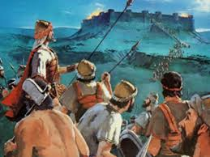
In the previous chapter, we learned that one man’s sin caused Israel’s defeat against Ai. People of Israel threw the stones against Achan’s family and his whole belongings and it became a pile of great heap of stones. In this way, sin among Israel was cleansed in the Valley of Achor. However, the spirit of Israelites’ camp became very heavy. Joshua must have been going through a tough time. He was concerned about how the past failure would affect his men. Joshua must have lost confidence and courage to re-engage in the battle against Ai. However, today we will learn about the LORD who encourages his people and lead them to victory.

- Read 8:1-9. What did God say to Joshua? (1-2) How was God's strategy different for conquering Ai? How did Joshua obey to God’s commands? (3-9)

1-1, Read 8:1-9.

Then the Lord said to Joshua, “Do not be afraid; do not be discouraged. Take the whole army with you, and go up and attack Ai. For I have delivered into your hands the king of Ai, his people, his city and his land. 2 You shall do to Ai and its king as you did to Jericho and its king, except that you may carry off their plunder and livestock for yourselves. Set an ambush behind the city.” 3 So Joshua and the whole army moved out to attack Ai. He chose thirty thousand of his best fighting men and sent them out at night 4 with these orders: “Listen carefully. You are to set an ambush behind the city. Don’t go very far from it. All of you be on the alert. 5 I and all those with me will advance on the city, and when the men come out against us, as they did before, we will flee from them. 6 They will pursue us until we have lured them away from the city, for they will say, ‘They are running away from us as they did before.’ So when we flee from them, 7 you are to rise up from ambush and take the city. The Lord your God will give it into your hand. 8 When you have taken the city, set it on fire. Do what the Lord has commanded. See to it; you have my orders.” 9 Then Joshua sent them off, and they went to the place of ambush and lay in wait between Bethel and Ai, to the west of Ai—but Joshua spent that night with the people.

1-2, What did God say to Joshua? (1-2)

Then the Lord said to Joshua, “Do not be afraid; do not be discouraged. Take the whole army with you, and go up and attack Ai. For I have delivered into your hands the king of Ai, his people, his city and his land. 2 You shall do to Ai and its king as you did to Jericho and its king, except that you may carry off their plunder and livestock for yourselves. Set an ambush behind the city.”

- God wanted Joshua to learn from failure and stand up from the place of frustration.
- What Joshua made fearful mostly was that he was not sure if God’s presence was still with him.
- That could make him fearful to continue to engage in conquering wars. Joshua saw and learned from the previous events that all the battles belong to God.
- If God’s presence leaves the community of Israel, there is no hope for him and for Israel. God knew Joshua’s discouragement.
- So God encouraged Joshua with his words. “Do not be afraid; do not be discouraged.”
- God encouraged him with the same words that he spoke in Joshua 1:9, “Be strong and courageous. Do not be afraid; do not be discouraged…”
- It shows God’s faithfulness and his love upon Joshua. When God saw that sin had been removed from Israel, God visited Joshua again and spoke to him to continue fighting against Ai.
- Failure is common to everyone. Though we fail sometimes, God’s faithfulness never fails. Our God is eager to give us cleansing, forgiveness, and strength.
- Joshua must have been greatly encouraged by the words of God and he received much.

1-3, How was God's strategy different for conquering Ai?

Take the whole army with you, and go up and attack Ai. For I have delivered into your hands the king of Ai, his people, his city and his land. 2 You shall do to Ai and its king as you did to Jericho and its king, except that you may carry off their plunder and livestock for yourselves. Set an ambush behind the city.”

- It was not like the battle against Jericho. All kinds of military strategies were used in the second battle such as luring, ambush and sudden attack.
- God used different strategies in each battle. That was why we need to accept one word each time so as to depend him newly.
- We should be careful to watch God’s leading hands upon each individual and on his ministry to follow God’s instruction on each situation.
- We should be always open our eyes and ears to learn from God, being open-minded to accommodate the opinions of others.

- In the first battle against Ai, Israel became proud and they miscalculated the numbers of soldiers to engage in the battle. As a result they had a bitter defeat.

- At this time, however, God wanted Joshua to take the whole army. It has spiritual meanings. Spiritual warfare should be done as a whole.
- God wants us to cooperate with one another to serve him and to serve the ministry of God. God’s people must also do their best in spiritual warfare.

- In Jericho battle, the Israelites were not allowed to take any of plunder from Jericho. But this time God allowed the Israelites to take the plunder for themselves.

- God’s another commend was to set an ambush behind the city. Here the word ambush appears many times in this chapter.
- In this battle, setting up the ambush was the key for the victory. Joshua’s soldiers performed this strategy for 2 nights without mistake.
- They perfectly concealed themselves from Ai soldiers and they were quick to action when Joshua’s attack signal was given to them.

1-4, How did Joshua obey to God’s commands? (3-9)
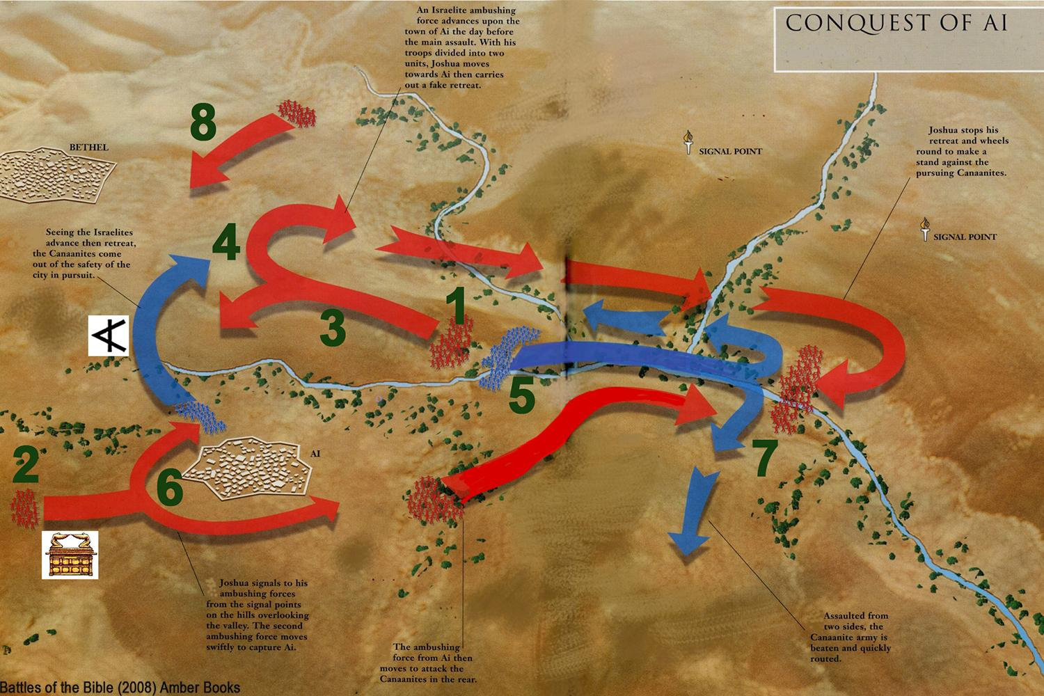

So Joshua and the whole army moved out to attack Ai. He chose thirty thousand of his best fighting men and sent them out at night 4 with these orders: “Listen carefully. You are to set an ambush behind the city. Don’t go very far from it. All of you be on the alert. 5 I and all those with me will advance on the city, and when the men come out against us, as they did before, we will flee from them. 6 They will pursue us until we have lured them away from the city, for they will say, ‘They are running away from us as they did before.’ So when we flee from them, 7 you are to rise up from ambush and take the city. The Lord your God will give it into your hand. 8 When you have taken the city, set it on fire. Do what the Lord has commanded. See to it; you have my orders.” 9 Then Joshua sent them off, and they went to the place of ambush and lay in wait between Bethel and Ai, to the west of Ai—but Joshua spent that night with the people.

- Joshua selected 30,000 soldiers. They were elite soldiers. That night they were placed behind the city of Ai to set an ambush. These 30,000 soldiers played an important role. They were asked to listen carefully and be alert!
- On Day 3, after taking over the city of Ai, they joined attacking the enemies from the rear side. They were truly valiant and good soldiers. They were helped to obey God’s command carefully.
- These well-trained 30,000 soldiers inspire us how we Christian soldiers should be like in attitude and shape spiritually.

2. Read verses 10-17. Where did Joshua position himself and the major part of the army? (10-11) Where was the ambush placed? (12-13) What did the king of Ai do when he saw Joshua's army? (14) How did Joshua lure all the men of Ai and Bethel to come out of their cities? (15-17)

2-1, Read verses 10-17.

Early the next morning Joshua mustered his army, and he and the leaders of Israel marched before them to Ai. 11 The entire force that was with him marched up and approached the city and arrived in front of it. They set up camp north of Ai, with the valley between them and the city. 12 Joshua had taken about five thousand men and set them in ambush between Bethel and Ai, to the west of the city. 13 So the soldiers took up their positions—with the main camp to the north of the city and the ambush to the west of it. That night Joshua went into the valley.
14 When the king of Ai saw this, he and all the men of the city hurried out early in the morning to meet Israel in battle at a certain place overlooking the Arabah. But he did not know that an ambush had been set against him behind the city. 15 Joshua and all Israel let themselves be driven back before them, and they fled toward the wilderness. 16 All the men of Ai were called to pursue them, and they pursued Joshua and were lured away from the city. 17 Not a man remained in Ai or Bethel who did not go after Israel. They left the city open and went in pursuit of Israel.

2-2, Where did Joshua position himself and the major part of the army? (10-11)

Early the next morning Joshua mustered his army, and he and the leaders of Israel marched before them to Ai. 11 The entire force that was with him marched up and approached the city and arrived in front of it. They set up camp north of Ai, with the valley between them and the city.

2-3, Where was the ambush placed? (12-13)

12 Joshua had taken about five thousand men and set them in ambush between Bethel and Ai, to the west of the city. 13 So the soldiers took up their positions—with the main camp to the north of the city and the ambush to the west of it. That night Joshua went into the valley.

- On Day 2, Joshua placed another detachment of soldiers in an ambush between Bethel and Ai.

2-4, What did the king of Ai do when he saw Joshua's army? (14)

14 When the king of Ai saw this, he and all the men of the city hurried out early in the morning to meet Israel in battle at a certain place overlooking the Arabah. But he did not know that an ambush had been set against him behind the city.

- On Day 3, the king of Ai with his men came out to meet the Israeli army. Battle began and all the men of Ai began chasing after the Israeli army not knowing there was an ambush.

2-5, How did Joshua lure all the men of Ai and Bethel to come out of their cities? (15-17)

15 Joshua and all Israel let themselves be driven back before them, and they fled toward the wilderness. 16 All the men of Ai were called to pursue them, and they pursued Joshua and were lured away from the city. 17 Not a man remained in Ai or Bethel who did not go after Israel. They left the city open and went in pursuit of Israel.

3. Read verses 18-35. What did the men in the ambush do when Joshua pointed his javelin toward Ai? (18-19) Describe the battle and its consequences. (20-29) What did all the Israelites do on Mount Ebal? What can we learn from them? (30-35)

3-1, Read verses 18-35.

Then the Lord said to Joshua, “Hold out toward Ai the javelin that is in your hand, for into your hand I will deliver the city.” So Joshua held out toward the city the javelin that was in his hand. 19 As soon as he did this, the men in the ambush rose quickly from their position and rushed forward. They entered the city and captured it and quickly set it on fire. 20 The men of Ai looked back and saw the smoke of the city rising up into the sky, but they had no chance to escape in any direction; the Israelites who had been fleeing toward the wilderness had turned back against their pursuers. 21 For when Joshua and all Israel saw that the ambush had taken the city and that smoke was going up from it, they turned around and attacked the men of Ai. 22 Those in the ambush also came out of the city against them, so that they were caught in the middle, with Israelites on both sides. Israel cut them down, leaving them neither survivors nor fugitives. 23 But they took the king of Ai alive and brought him to Joshua. 24 When Israel had finished killing all the men of Ai in the fields and in the wilderness where they had chased them, and when every one of them had been put to the sword, all the Israelites returned to Ai and killed those who were in it. 25 Twelve thousand men and women fell that day—all the people of Ai.26 For Joshua did not draw back the hand that held out his javelin until he had destroyed[a] all who lived in Ai. 27 But Israel did carry off for themselves the livestock and plunder of this city, as the Lord had instructed Joshua. 28 So Joshua burned Ai[b] and made it a permanent heap of ruins, a desolate place to this day. 29 He impaled the body of the king of Ai on a pole and left it there until evening. At sunset, Joshua ordered them to take the body from the pole and throw it down at the entrance of the city gate. And they raised a large pile of rocks over it, which remains to this day.

The Covenant Renewed at Mount Ebal
30 Then Joshua built on Mount Ebal an altar to the Lord, the God of Israel, 31 as Moses the servant of the Lord had commanded the Israelites. He built it according to what is written in the Book of the Law of Moses—an altar of uncut stones, on which no iron tool had been used. On it they offered to the Lord burnt offerings and sacrificed fellowship offerings. 32 There, in the presence of the Israelites, Joshua wrote on stones a copy of the law of Moses. 33 All the Israelites, with their elders, officials and judges, were standing on both sides of the ark of the covenant of the Lord, facing the Levitical priests who carried it. Both the foreigners living among them and the native-born were there. Half of the people stood in front of Mount Gerizim and half of them in front of Mount Ebal, as Moses the servant of the Lord had formerly commanded when he gave instructions to bless the people of Israel. 34 Afterward, Joshua read all the words of the law—the blessings and the curses—just as it is written in the Book of the Law. 35 There was not a word of all that Moses had commanded that Joshua did not read to the whole assembly of Israel, including the women and children, and the foreigners who lived among them.

3-2, What did the men in the ambush do when Joshua pointed his javelin toward Ai? (18-19)

Then the Lord said to Joshua, “Hold out toward Ai the javelin that is in your hand, for into your hand I will deliver the city.” So Joshua held out toward the city the javelin that was in his hand. 19 As soon as he did this, the men in the ambush rose quickly from their position and rushed forward. They entered the city and captured it and quickly set it on fire.

- No sooner had Joshua held out toward the city the javelin than the men in the ambush rose quickly from their position and rushed forward and entered the city and captured it and quickly set it on fire.
- It is like spiritual soldiers who are very sensitive to the work of the Holy Spirit to reply quickly.
- Joshua did not draw back the javelin in verse 26 until victory is complete! When we fix our eyes on Jesus and His cross, the same victory is ours!

3-3, Describe the battle and its consequences. (20-29)

20 The men of Ai looked back and saw the smoke of the city rising up into the sky, but they had no chance to escape in any direction; the Israelites who had been fleeing toward the wilderness had turned back against their pursuers. 21 For when Joshua and all Israel saw that the ambush had taken the city and that smoke was going up from it, they turned around and attacked the men of Ai. 22 Those in the ambush also came out of the city against them, so that they were caught in the middle, with Israelites on both sides. Israel cut them down, leaving them neither survivors nor fugitives. 23 But they took the king of Ai alive and brought him to Joshua. 24 When Israel had finished killing all the men of Ai in the fields and in the wilderness where they had chased them, and when every one of them had been put to the sword, all the Israelites returned to Ai and killed those who were in it. 25 Twelve thousand men and women fell that day—all the people of Ai. 26 For Joshua did not draw back the hand that held out his javelin until he had destroyed[a] all who lived in Ai. 27 But Israel did carry off for themselves the livestock and plunder of this city, as the Lord had instructed Joshua. 28 So Joshua burned Ai[b] and made it a permanent heap of ruins, a desolate place to this day. 29 He impaled the body of the king of Ai on a pole and left it there until evening. At sunset, Joshua ordered them to take the body from the pole and throw it down at the entrance of the city gate. And they raised a large pile of rocks over it, which remains to this day.

- In these verses we find General Joshua as a spirit filled leader fully trusting God alone.
- In the previous chapter, General Joshua listened to the recommendation of some spies who were sent out to Ai. He depended on human wisdom. Then his army failed.
- This time General Joshua was with God and followed his instructions. He received God’s words of instruction in verse 18. “Hold out toward Ai the javelin that is in your hand, for into your hand I will deliver the city.”
- Joshua obeyed God’s command by holding out his javelin toward the city of Ai. And it became a signal for the ambushed soldiers to take an immediate action to take the city of Ai.
- He didn’t draw back his hand holding the javelin until their operation was over. The body of the king of Ai was impaled on a pole until evening and thrown down at sunset.
- A large pile of rocks was raised over the dead body. He successfully carried out the operation Ai according to God’s instruction.

3-4, What did all the Israelites do on Mount Ebal?
3-5, What can we learn from them? (30-35)

30 Then Joshua built on Mount Ebal an altar to the Lord, the God of Israel, 31 as Moses the servant of the Lord had commanded the Israelites. He built it according to what is written in the Book of the Law of Moses—an altar of uncut stones, on which no iron tool had been used. On it they offered to the Lord burnt offerings and sacrificed fellowship offerings. 32 There, in the presence of the Israelites, Joshua wrote on stones a copy of the law of Moses. 33 All the Israelites, with their elders, officials and judges, were standing on both sides of the ark of the covenant of the Lord, facing the Levitical priests who carried it. Both the foreigners living among them and the native-born were there. Half of the people stood in front of Mount Gerizim and half of them in front of Mount Ebal, as Moses the servant of the Lord had formerly commanded when he gave instructions to bless the people of Israel. 34 Afterward, Joshua read all the words of the law—the blessings and the curses—just as it is written in the Book of the Law. 35 There was not a word of all that Moses had commanded that Joshua did not read to the whole assembly of Israel, including the women and children, and the foreigners who lived among them.

- After the battle, Joshua led all his people to go to Mount Ebal. It was a risky thing to do because Mount Ebal was located deep inside the Promised Land. And the large number of all the Israelites including women and children had to make a long journey in the middle of warfare.
- It was more reasonable to wait until knocking down more cities using the momentum. But he didn’t do so. He and his people were willing to go to Mount Ebal and worship the LORD as Moses commanded before.

- Six tribes stood on Mount Gerizim to respond by happy and loud “Amens” when the law of the blessings was recited verse by verse.
- The other six tribes stood on Mount Ebal to respond by solemn and heavy “Amens” when the law of the curses was recited verse by verse. Joshua and Levitical priests were standing in the valley which is Shechem.

- About 1400 years later, Jesus met one of the descendants of these people suffering under many curses.
- We don’t know her name. She was a Samaritan woman. She was thirsty. She came out to draw water.
- In fact, she had 5 husbands in the past. She was hated by the villagers. She was a sinful woman suffering much because of her own sins.
- But Jesus gave her a spring of water welling up to eternal life. He revealed himself to her as the Messiah. Jesus forgave her and freed her from the curses caused by her own sins and her forefathers’ sins.
- He also met with the villagers later and revealed himself to them. He removed all the curses upon them when they accepted him as the Messiah.

- Jesus was able to do this because he himself took all the sins of the world. He became a curse for us so that we may have peace in Him.

Galatians 3:13 says,

“Christ redeemed us from the curse of the law by becoming a curse for us, for it is written: ‘Cursed is everyone who is hung on a pole.’”

Conclusion

Throughout the passage, God revealed His own glory in the battle of Ai. The word, “ambush” is repeated throughout the passage. In the similar way, God set a ambush army, on college campuses, for each campus is like Ai in light of small population up to range from 10k to 50k. However, college campus is very important and it is not easy to conquer it with ordinary way unless best fighting army engage in fierce battle by obedience and absolute faith. Likewise we are called in our times like ambush army soldiers by God to be best Bible teachers and be ready for fierce spiritual battle against the hub of dark forces on campus. May the Lord help us to be ready as obedient and best fighting ambush soldiers in our times to serve all campuses by starting from liberal California campuses. May the Lord bless America to be a kingdom of priests.

One word: Set a ambush!

