BE STRONG AND COURAGEOUS

Joshua 1:1-18
Key Verse 6

Be strong and courageous, because you will lead these people to inherit the land I swore to their ancestors to give them.

Introduction

After studying the book of 1 Thessalonians, we will study the book of Joshua because when we prayed about which book to study next, we came up with this book to grow as good soldiers of Jesus Christ in 2019. As we began 2019 with a couple of lessons, we would like to know our Lord Jesus Christ and pray always without giving up. Now we want to be strong and courageous for world mission and campus ministry. May the Lord help each of us to pick up soldier’s spirit so that we may engage in spiritual battle to advance the kingdom of God continually. Amen.

- Read verses 1-5. What command did the Lord give Joshua? (1-2) What did God promise to give him? (3-4, Dt 11:24-25) What does it mean that God would be with him?

1-1, Read verses 1-5.

After the death of Moses the servant of the Lord, the Lord said to Joshua son of Nun, Moses’ aide: 2 “Moses my servant is dead. Now then, you and all these people, get ready to cross the Jordan River into the land I am about to give to them—to the Israelites. 3 I will give you every place where you set your foot, as I promised Moses. 4 Your territory will extend from the desert to Lebanon, and from the great river, the Euphrates—all the Hittite country—to the Mediterranean Sea in the west. 5 No one will be able to stand against you all the days of your life. As I was with Moses, so I will be with you; I will never leave you nor forsake you.

1-2, What command did the Lord give Joshua? (1-2)

After the death of Moses the servant of the Lord, the Lord said to Joshua son of Nun, Moses’ aide: 2 “Moses my servant is dead. Now then, you and all these people, get ready to cross the Jordan River into the land I am about to give to them—to the Israelites.

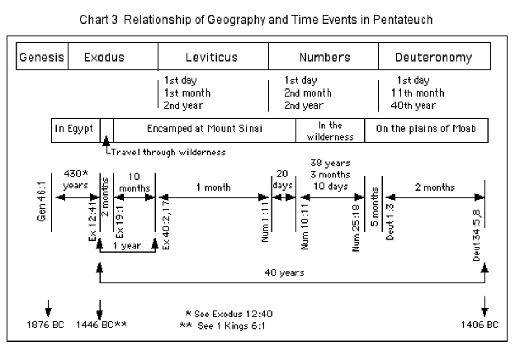

- The book of Joshua is sixth book after Moses’ 5 books. Since God promised to Abraham more than 430 years ago, time finally came for the Israelites to enter the Canaan land.
- However, due to unbelief, they were not able to enter the land about 40 years ago. They had to wander in the wilderness as the book of Numbers explained.
- This book began with the phrase, “after the death of Moses, the servant of the Lord”
- Moses was called by God and led the Israelites out of Egypt. He had to suffer a lot because of rebellious and unbelieving people.
- He was not allowed to enter the promised land. Now God raised up Moses’ successor to lead the people instead.

“The Lord said to Joshua son of Nun, Moses’ aide: 2 “Moses my servant is dead. Now then, you and all these people, get ready to cross the Jordan River into the land I am about to give to them—to the Israelites.”

- Joshua is introduced as Moses’ aide. Joshua had a learning mind to learn from his senior, Moses. At God’s time, he had to lead the people to get ready to cross the Jordan River into the land God was about to give to the Israelites.
- Joshua was not a young man at this time. He had spent his entire career previously as the assistant of Moses. Now he finds that it is his time to lead, but only after God prepared him.
- God’s word and God’s holy mission was given to Joshua. Just as Moses served God’s command although he thought that he wasn’t capable of doing it, Joshua had to step up as a leader according to God’s command. He might have said that he would assist Moses as his aide only.
- But God appeared to him and spoke to him in person after Moses was gone. Each person need to hear God’s word through accepting God’s solemn command before taking mission. Otherwise, we end up confusing or waving about our calling. May the Lord help us to hear God’s word and be confident about his call.

1-3, What did God promise to give him? (3-4, Dt 11:24-25)

3 I will give you every place where you set your foot, as I promised Moses. 4 Your territory will extend from the desert to Lebanon, and from the great river, the Euphrates—all the Hittite country—to the Mediterranean Sea in the west.

24 Every place where you set your foot will be yours: Your territory will extend from the desert to Lebanon, and from the Euphrates River to the Mediterranean Sea. 25 No one will be able to stand against you. The Lord your God, as he promised you, will put the terror and fear of you on the whole land, wherever you go. (Deuteronmy 11:24-25)

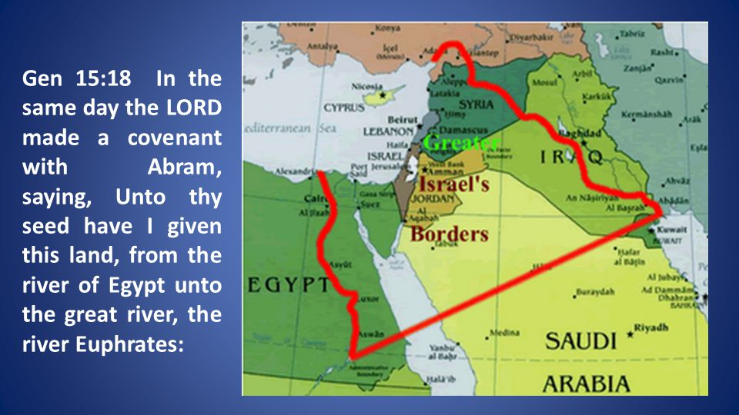

- We can not but remind of Genesis 15 about God’s original promise to Abraham.

After this, the word of the Lord came to Abram in a vision: “Do not be afraid, Abram. I am your shield, your very great reward.” 2 But Abram said, “Sovereign Lord, what can you give me since I remain childless and the one who will inherit my estate is Eliezer of Damascus?” 3 And Abram said, “You have given me no children; so a servant in my household will be my heir.” 4 Then the word of the Lord came to him: “This man will not be your heir, but a son who is your own flesh and blood will be your heir.” 5 He took him outside and said, “Look up at the sky and count the stars—if indeed you can count them.” Then he said to him, “So shall your offspring be.” 6 Abram believed the Lord, and he credited it to him as righteousness. 7 He also said to him, “I am the Lord, who brought you out of Ur of the Chaldeans to give you this land to take possession of it.” 8 But Abram said, “Sovereign Lord, how can I know that I will gain possession of it?” 9 So the Lord said to him, “Bring me a heifer, a goat and a ram, each three years old, along with a dove and a young pigeon.” 10 Abram brought all these to him, cut them in two and arranged the halves opposite each other; the birds, however, he did not cut in half. 11 Then birds of prey came down on the carcasses, but Abram drove them away. 12 As the sun was setting, Abram fell into a deep sleep, and a thick and dreadful darkness came over him. 13 Then the Lord said to him, “Know for certain that for four hundred years your descendants will be strangers in a country not their own and that they will be enslaved and mistreated there. 14 But I will punish the nation they serve as slaves, and afterward they will come out with great possessions. 15 You, however, will go to your ancestors in peace and be buried at a good old age. 16 In the fourth generation your descendants will come back here, for the sin of the Amorites has not yet reached its full measure.” 17 When the sun had set and darkness had fallen, a smoking firepot with a blazing torch appeared and passed between the pieces. 18 On that day the Lord made a covenant with Abram and said, “To your descendants I give this land, from the Wadi of Egypt to the great river, the Euphrates— 19 the land of the Kenites, Kenizzites, Kadmonites, 20 Hittites, Perizzites, Rephaites, 21 Amorites, Canaanites, Girgashites and Jebusites.”

- We must set our feet on our mission field by faith like the Israelites. Just as God promised to Abraham and Moses, Joshua put into trust God and God’s promises.
- The whole land was given, but they could only possess that which they claimed. What they took must be fought for against a determined opposition from enemies.
- God could have simply eliminated all their enemies with his mighty words. But he called Israel into partnership with Himself to see His will done.
- The challenge ahead was not for those who were content with Egypt, but for those who would press ahead for what God had called them to do.
- It may remind us of Philippians 3:12-14. “Not that I have already obtained all this, or have already arrived at my goal, but I press on to take hold of that for which Christ Jesus took hold of me. 13 Brothers and sisters, I do not consider myself yet to have taken hold of it. But one thing I do: Forgetting what is behind and straining toward what is ahead, 14 I press on toward the goal to win the prize for which God has called me heavenward in Christ Jesus.”

1-4, What does it mean that God would be with him?

5 No one will be able to stand against you all the days of your life. As I was with Moses, so I will be with you; I will never leave you nor forsake you.

- Joshua could have relied on his prior experience as a soldier or Moses’ aide. But God reminded him of who God is first. As I was with Moses, so I will be with you.
- God will never leave him nor forsake him. It is his great God who will be with him always. It reminds us of Matt 28:18-20. Then Jesus came to them and said, “All authority in heaven and on earth has been given to me. Therefore go and make disciples of all nations, baptizing them in the name of the Father and of the Son and of the Holy Spirit, and teaching them to obey everything I have commanded you. And surely I am with you always, to the very end of the age.”
- May the Lord help us to put into trust in the Lord God who promised to be with us in serving Him always. Amen.

2. Read verses 6-9. Why did the Lord repeatedly command Joshua to be strong and courageous? What further instructions did the Lord God give him to be prosperous and successful? (Deuteronomy 24:22-23)

2-1, Read verses 6-9.

Be strong and courageous, because you will lead these people to inherit the land I swore to their ancestors to give them. 7 “Be strong and very courageous. Be careful to obey all the law my servant Moses gave you; do not turn from it to the right or to the left, that you may be successful wherever you go. 8 Keep this Book of the Law always on your lips; meditate on it day and night, so that you may be careful to do everything written in it. Then you will be prosperous and successful. 9 Have I not commanded you? Be strong and courageous. Do not be afraid; do not be discouraged, for the Lord your God will be with you wherever you go.”

2-2, Why did the Lord repeatedly command Joshua to be strong and courageous?

Be strong and courageous, because you will lead these people to inherit the land I swore to their ancestors to give them. 7 “Be strong and very courageous. Be careful to obey all the law my servant Moses gave you; do not turn from it to the right or to the left, that you may be successful wherever you go. 8 Keep this Book of the Law always on your lips; meditate on it day and night, so that you may be careful to do everything written in it. Then you will be prosperous and successful. 9 Have I not commanded you? Be strong and courageous. Do not be afraid; do not be discouraged, for the Lord your God will be with you wherever you go.”

- The Lord God repeated it up to three times in verses 6, 7, and 9. God must have understood where Joshua came from. Although he was called by God, he must have been burdensome to lead the Israelites.
- It must have been very challenging for him to lead this new generation to the promised land where strong and even giant enemies are defending.
- Joshua was called to be strong and courageous for God’s name. It was the words of encouragement that Joshua needed the most.
- This bold courage would be in Joshua himself, but in God. We can be full of self confidence that will take us to ruin. But we should instead be full of a genuine confidence by faith.

2-3, What further instructions did the Lord God give him to be prosperous and successful? (Deuteronomy 11:22-23)

If you carefully observe all these commands I am giving you to follow—to love the Lord your God, to walk in obedience to him and to hold fast to him— 23 then the Lord will drive out all these nations before you, and you will dispossess nations larger and stronger than you. (Deuteronmy 11:22-23)

Be careful to obey all the law my servant Moses gave you; do not turn from it to the right or to the left, that you may be successful wherever you go. 8 Keep this Book of the Law always on your lips; meditate on it day and night, so that you may be careful to do everything written in it. Then you will be prosperous and successful. 9 Have I not commanded you? Be strong and courageous. Do not be afraid; do not be discouraged, for the Lord your God will be with you wherever you go.”

- God told Joshua to be careful to obey all the law Moses gave to his people. God told him not to depart from God’s law either to the right or to the left.
- Now this sounds impractical, since Joshua was a military leader. Joshua was not appointed as a Bible scholar. He had to secure military victory.
- However, the secret of his military success was in following the word of God. It was because God himself would fight for them according to the word of promise.
- As the commander-in-chief, Joshua had many things to do, but the most important thing he had to do each and every day was to meditate on the word of God day and night.
- Joshua was to mediate the word of God with great diligence. God said, “Then you will be prosperous and successful.”
- Joshua followed God’s words. He studied the Bible and obeyed God faithfully. Then Joshua was prosperous and successful.
- God wants to give us success in whatever we do. It begins through diligent Bible study. This is the very secret of success that God blesses.

Be careful to obey all the law my servant Moses gave you; do not turn from it to the right or to the left

Keep this Book of the Law always on your lips; meditate on it day and night, so that you may be careful to do everything written in it.

- Joshua must take great care to observe the law. God’s word and Joshua’s commitment to it would be the pillars supporting his success.
- To all the law: Joshua did not only need to read God’s word according to his preference like “pick and choose” atttitue. He should read and obey all the law.
- It had to be on his lips(shall not depart from your mouth), in his mind (meditate in it day and night), and he had to do it (observe to do according to all that is written).

3. Read verses 10-18. How did Joshua obey God's command? (10-11) What were the the tribes of Reuben, Gad and the half-tribe of Manasseh asked to do? Why? (12-15) How did the people respond? (16-18)

3-1, Read verses 10-18.

So Joshua ordered the officers of the people: 11 “Go through the camp and tell the people, ‘Get your provisions ready. Three days from now you will cross the Jordan here to go in and take possession of the land the Lord your God is giving you for your own.’”
12 But to the Reubenites, the Gadites and the half-tribe of Manasseh, Joshua said, 13 “Remember the command that Moses the servant of the Lord gave you after he said, ‘The Lord your God will give you rest by giving you this land.’ 14 Your wives, your children and your livestock may stay in the land that Moses gave you east of the Jordan, but all your fighting men, ready for battle, must cross over ahead of your fellow Israelites. You are to help them 15 until the Lord gives them rest, as he has done for you, and until they too have taken possession of the land the Lord your God is giving them. After that, you may go back and occupy your own land, which Moses the servant of the Lord gave you east of the Jordan toward the sunrise.” 16 Then they answered Joshua, “Whatever you have commanded us we will do, and wherever you send us we will go. 17 Just as we fully obeyed Moses, so we will obey you. Only may the Lord your God be with you as he was with Moses. 18 Whoever rebels against your word and does not obey it, whatever you may command them, will be put to death. Only be strong and courageous!”

3-2, How did Joshua obey God's command? (10-11)

So Joshua ordered the officers of the people: 11 “Go through the camp and tell the people, ‘Get your provisions ready. Three days from now you will cross the Jordan here to go in and take possession of the land the Lord your God is giving you for your own.’”

- This passage shows that Joshua accepted God’s command personally and deeply. No sooner had he received God’s command than he ordered the officers of the people to take action.
- Get your provisions ready. Three days from now you will cross the Jordan here to go in and take possession of the land the Lord your God is giving you for your own. May the Lord help us to be obedient and prepared for God’s battle diligently.

3-3, What were the the tribes of Reuben, Gad and the half-tribe of Manasseh asked to do? Why? (12-15)

12 But to the Reubenites, the Gadites and the half-tribe of Manasseh, Joshua said, 13 “Remember the command that Moses the servant of the Lord gave you after he said, ‘The Lord your God will give you rest by giving you this land.’ 14 Your wives, your children and your livestock may stay in the land that Moses gave you east of the Jordan, but all your fighting men, ready for battle, must cross over ahead of your fellow Israelites. You are to help them 15 until the Lord gives them rest, as he has done for you, and until they too have taken possession of the land the Lord your God is giving them. After that, you may go back and occupy your own land, which Moses the servant of the Lord gave you east of the Jordan toward the sunrise.”

- Joshua promoted a sense of unity by reminding three tribes of what Moses had helped him before.
- According to prior agreement between Moses and them, Joshua encouraged them to keep their promise for God’s glory.

1 Corinthians 12:24-25 reads,

“while our presentable parts need no special treatment. But God has put the body together, giving greater honor to the parts that lacked it, 25 so that there should be no division in the body, but that its parts should have equal concern for each other. 26 If one part suffers, every part suffers with it; if one part is honored, every part rejoices with it.”

3-4, How did the people respond? (16-18)

16 Then they answered Joshua, “Whatever you have commanded us we will do, and wherever you send us we will go. 17 Just as we fully obeyed Moses, so we will obey you. Only may the Lord your God be with you as he was with Moses. 18 Whoever rebels against your word and does not obey it, whatever you may command them, will be put to death. Only be strong and courageous!”

- When Moses was obedient to God’s command, Joshua was obedient as his learner. When Joshua was obedient, the people learned and were obedient.
- They even encouraged Joshua to be strong and courageous only because they believed God working among them.
- Because they picked up faith in God who blessed Joshua, they were able to obey God’s servant, Joshua.
- Here we also see Israel in an unified nation to fulfill God’s calling and promise for them. They overcame the temptation to see the eastern tribes as separate from the rest of Israel.

Conclusion

Thank God who raises up His servants to serve salvation work. Serving God’s redemptive work is not an easy task because of obstacles here and there. However God promises to be with us always and encourages us to be strong and courageous always. May the Lord help us to carefully follow His words of promise so as to claim His land one by one. May the Lord help us to grow as good soldiers of Jesus Christ in 2019.

One word: Be strong!

