DEDICATION OF THE WALL OF JERUSALEM

Nehemiah 11:1-12:47
Key verse 12:27

At the dedication of the wall of Jerusalem, the Levites were sought out from where they lived and were brought to Jerusalem to celebrate joyfully the dedication with songs of thanksgiving and with the music of cymbals, harps and lyres.

Introduction
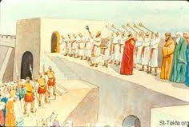
Today’s passage is about the repopulating Jerusalem and the dedication of the wall of Jerusalem. God’s people are in the process of completely restoring their relationship with God and in their identity as God’s people. The house of God was rebuilt. But who would fill them and bring life to them? Offerings and titles were plenty. But who would offer their own lives and families to actually live within the walls of the city? Who would offer their lives and families from among those who were consecrated to the Lord to live within the temple walls and perform the numerous duties required to upkeep the house of God? Once Jesus said, “The harvest is plentiful, but the workers are few. Ask the Lord of the harvest, therefore, to send out workers into his harvest field.” (Lk. 10:2) It would take dedicated sacrificial workers ready to give their lives. And so the bravest of hearts volunteered to be uprooted from the comforts of their rural homes and to settle in Jerusalem and the house of God. And when their numbers were not enough, others were chosen by divine lot to fill in what was required. Either way, chapters 11 and 12 is a divine record of those whose sacrifices made spiritual history. It resulted in great joy!

- Read verses 11:1-36. How did Nehemiah successfully carry out his settlement plan in Jerusalem? (1-2) Who were the list of God’s people that settled in and around Jerusalem? (3-36) What can we learn from them through this process?

1-1, Read verses 11:1-36.

Now the leaders of the people settled in Jerusalem. The rest of the people cast lots to bring one out of every ten of them to live in Jerusalem, the holy city, while the remaining nine were to stay in their own towns. 2 The people commended all who volunteered to live in Jerusalem. 3 These are the provincial leaders who settled in Jerusalem (now some Israelites, priests, Levites, temple servants and descendants of Solomon’s servants lived in the towns of Judah, each on their own property in the various towns, 4 while other people from both Judah and Benjamin lived in Jerusalem):

From the descendants of Judah:
Athaiah son of Uzziah, the son of Zechariah, the son of Amariah, the son of Shephatiah, the son of Mahalalel, a descendant of Perez; 5 and Maaseiah son of Baruch, the son of Kol-Hozeh, the son of Hazaiah, the son of Adaiah, the son of Joiarib, the son of Zechariah, a descendant of Shelah. 6 The descendants of Perez who lived in Jerusalem totaled 468 men of standing.
7 From the descendants of Benjamin:
Sallu son of Meshullam, the son of Joed, the son of Pedaiah, the son of Kolaiah, the son of Maaseiah, the son of Ithiel, the son of Jeshaiah, 8 and his followers, Gabbai and Sallai—928 men. 9 Joel son of Zikri was their chief officer, and Judah son of Hassenuah was over the New Quarter of the city.
10 From the priests:
Jedaiah; the son of Joiarib; Jakin; 11 Seraiah son of Hilkiah, the son of Meshullam, the son of Zadok, the son of Meraioth, the son of Ahitub, the official in charge of the house of God, 12 and their associates, who carried on work for the temple—822 men; Adaiah son of Jeroham, the son of Pelaliah, the son of Amzi, the son of Zechariah, the son of Pashhur, the son of Malkijah, 13 and his associates, who were heads of families—242 men; Amashsai son of Azarel, the son of Ahzai, the son of Meshillemoth, the son of Immer, 14 and his[a] associates, who were men of standing—128. Their chief officer was Zabdiel son of Haggedolim.
15 From the Levites:
Shemaiah son of Hasshub, the son of Azrikam, the son of Hashabiah, the son of Bunni; 16 Shabbethai and Jozabad, two of the heads of the Levites, who had charge of the outside work of the house of God;17 Mattaniah son of Mika, the son of Zabdi, the son of Asaph, the director who led in thanksgiving and prayer; Bakbukiah, second among his associates; and Abda son of Shammua, the son of Galal, the son of Jeduthun. 18 The Levites in the holy city totaled 284.
19 The gatekeepers:
Akkub, Talmon and their associates, who kept watch at the gates—172 men.
20 The rest of the Israelites, with the priests and Levites, were in all the towns of Judah, each on their ancestral property.
21 The temple servants lived on the hill of Ophel, and Ziha and Gishpa were in charge of them.
22 The chief officer of the Levites in Jerusalem was Uzzi son of Bani, the son of Hashabiah, the son of Mattaniah, the son of Mika. Uzzi was one of Asaph’s descendants, who were the musicians responsible for the service of the house of God. 23 The musicians were under the king’s orders, which regulated their daily activity.
24 Pethahiah son of Meshezabel, one of the descendants of Zerah son of Judah, was the king’s agent in all affairs relating to the people.
25 As for the villages with their fields, some of the people of Judah lived in Kiriath Arba and its surrounding settlements, in Dibon and its settlements, in Jekabzeel and its villages, 26 in Jeshua, in Moladah, in Beth Pelet, 27 in Hazar Shual, in Beersheba and its settlements, 28 in Ziklag, in Mekonah and its settlements, 29 in En Rimmon, in Zorah, in Jarmuth, 30 Zanoah, Adullam and their villages, in Lachish and its fields, and in Azekah and its settlements. So they were living all the way from Beersheba to the Valley of Hinnom.
31 The descendants of the Benjamites from Geba lived in Mikmash, Aija, Bethel and its settlements, 32 in Anathoth, Nob and Ananiah, 33 in Hazor, Ramah and Gittaim, 34 in Hadid, Zeboim and Neballat, 35 in Lod and Ono, and in Ge Harashim.
36 Some of the divisions of the Levites of Judah settled in Benjamin.

1-2, How did Nehemiah successfully carry out his settlement plan in Jerusalem? (1-2)

Now the leaders of the people settled in Jerusalem. The rest of the people cast lots to bring one out of every ten of them to live in Jerusalem, the holy city, while the remaining nine were to stay in their own towns. 2 The people commended all who volunteered to live in Jerusalem.

- The city wall has been rebuilt and Jerusalem has become a well-defended city. But Nehemiah found a problem that it was a city without people.
- Imagine a holy city without people—a ghost town. The solution should be to draft families to move there.
- The leaders of the people settled in Jerusalem and the rest of the people cast lots to bring one out of every ten to live in Jerusalem, while the remaining nine were to live in their own towns.

- It was a voluntary draft—casting lots first, then according to verse 2, volunteering to live in Jerusalem.
- But it was not easy for the Israelites to give up their houses in their towns and move into Jerusalem.
- Living in Jerusalem meant that they were to defend the city from enemies’ attacks and to take care of it as a holy city.
- To live in Jerusalem, they had to give yup land in the previous area and take up some kind of new way of living(house and job) in Jerusalem.
- To live in Jerusalem, they had to re-arrange their social priorities, certainly leaving some friends and family behind in their old villages.
- Due to the wall and the gates, their freedom and privacy would be greatly restricted. So those who volunteered were then commended by the people.
- In spite of all these difficulties, God promised to bless them more than they possibly imagine or handle as described in Revelation 21:1-5.

Revelation 21:1-5 reads,

Then I saw “a new heaven and a new earth,”[a] for the first heaven and the first earth had passed away, and there was no longer any sea. 2 I saw the Holy City, the new Jerusalem, coming down out of heaven from God, prepared as a bride beautifully dressed for her husband. 3 And I heard a loud voice from the throne saying, “Look! God’s dwelling place is now among the people, and he will dwell with them. They will be his people, and God himself will be with them and be their God. 4 ‘He will wipe every tear from their eyes. There will be no more death’[b] or mourning or crying or pain, for the old order of things has passed away.” 5 He who was seated on the throne said, “I am making everything new!” Then he said, “Write this down, for these words are trustworthy and true.”

1-3, Who were the list of God’s people that settled in and around Jerusalem? (3-36)

- This extensive list includes tribal leaders (of the tribes of Judah and Benjamin), military men, priests, Levites, gatekeepers, and civil and royal servants.
- All these notable men and their families took the lead by choosing to settle in Jerusalem, setting a good example for all God’s people.
- 468 families from the descendants of Judah and 928 families from the descendants of Benjamin were chosen and volunteered to live in Jerusalem.
- Then for their spiritual strength, 1192 priests and 284 Levites were chosen to live in Jerusalem along with 284 gatekeepers.

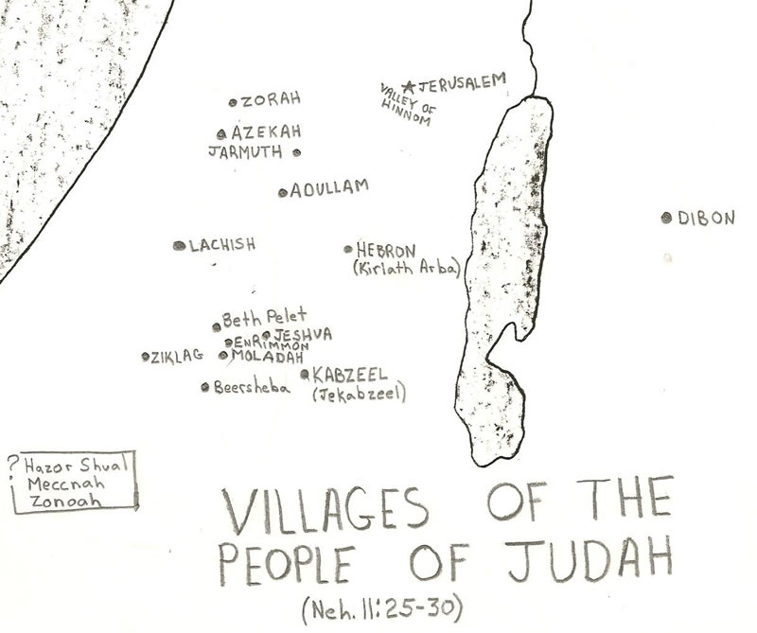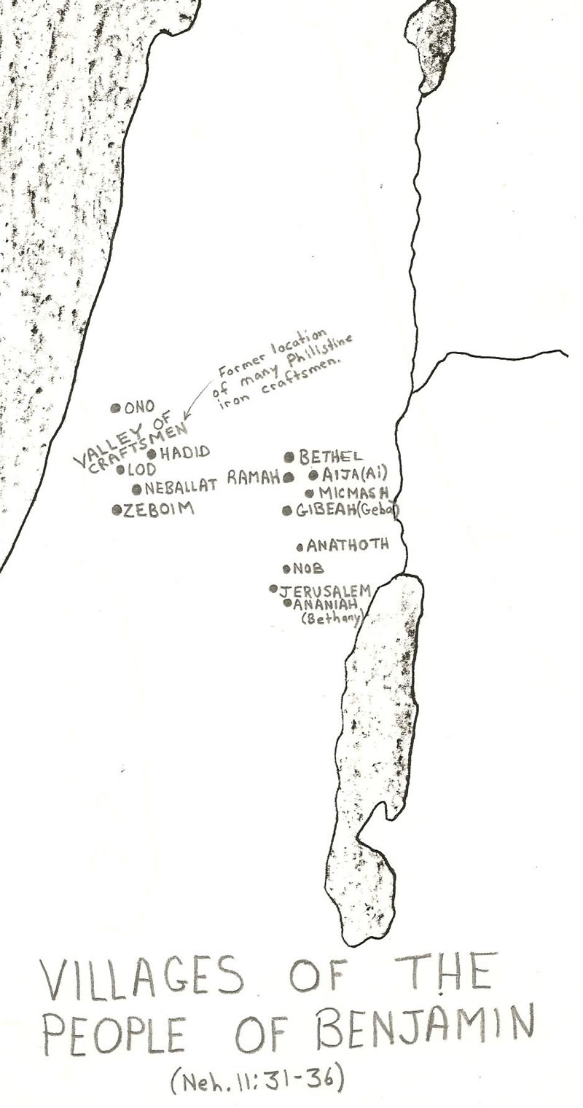

1-4, What can we learn from them through this process?

- These chosen volunteers settled in Jerusalem. God’s work is the work of voluntary drafts.
- We Christians are drafted and chosen for the New Jerusalem by God’s grace alone, and God wants us to volunteer for his soul saving work.
- We thank God for many people who volunteered to serve such as sound booth, orchestra, or special songs.
- Let us volunteer to become God’s servants for God’s rescue mission to work together to save perishing souls on campus with corporate effort.

2. Read verses 12:1-42. What did Nehemiah prepare for the dedication of the wall of Jerusalem? (12:1-26) How was the dedication of the wall celebrated? (27-42)

2-1, Read verses 12:1-42.

These were the priests and Levites who returned with Zerubbabel son of Shealtiel and with Joshua:
Seraiah, Jeremiah, Ezra,
2 Amariah, Malluk, Hattush,
3 Shekaniah, Rehum, Meremoth,
4 Iddo, Ginnethon,[a] Abijah,
5 Mijamin,[b] Moadiah, Bilgah,
6 Shemaiah, Joiarib, Jedaiah,
7 Sallu, Amok, Hilkiah and Jedaiah.
These were the leaders of the priests and their associates in the days of Joshua.
8 The Levites were Jeshua, Binnui, Kadmiel, Sherebiah, Judah, and also Mattaniah, who, together with his associates, was in charge of the songs of thanksgiving. 9 Bakbukiah and Unni, their associates, stood opposite them in the services.
10 Joshua was the father of Joiakim, Joiakim the father of Eliashib, Eliashib the father of Joiada, 11 Joiada the father of Jonathan, and Jonathan the father of Jaddua.
12 In the days of Joiakim, these were the heads of the priestly families:
of Seraiah’s family, Meraiah;
of Jeremiah’s, Hananiah;
13 of Ezra’s, Meshullam;
of Amariah’s, Jehohanan;
14 of Malluk’s, Jonathan;
of Shekaniah’s,[c] Joseph;
15 of Harim’s, Adna;
of Meremoth’s,[d] Helkai;
16 of Iddo’s, Zechariah;
of Ginnethon’s, Meshullam;
17 of Abijah’s, Zikri;
of Miniamin’s and of Moadiah’s, Piltai;
18 of Bilgah’s, Shammua;
of Shemaiah’s, Jehonathan;
19 of Joiarib’s, Mattenai;
of Jedaiah’s, Uzzi;
20 of Sallu’s, Kallai;
of Amok’s, Eber;
21 of Hilkiah’s, Hashabiah;
of Jedaiah’s, Nethanel.
22 The family heads of the Levites in the days of Eliashib, Joiada, Johanan and Jaddua, as well as those of the priests, were recorded in the reign of Darius the Persian. 23 The family heads among the descendants of Levi up to the time of Johanan son of Eliashib were recorded in the book of the annals. 24 And the leaders of the Levites were Hashabiah, Sherebiah, Jeshua son of Kadmiel, and their associates, who stood opposite them to give praise and thanksgiving, one section responding to the other, as prescribed by David the man of God.
25 Mattaniah, Bakbukiah, Obadiah, Meshullam, Talmon and Akkub were gatekeepers who guarded the storerooms at the gates. 26 They served in the days of Joiakim son of Joshua, the son of Jozadak, and in the days of Nehemiah the governor and of Ezra the priest, the teacher of the Law.

Dedication of the Wall of Jerusalem
27 At the dedication of the wall of Jerusalem, the Levites were sought out from where they lived and were brought to Jerusalem to celebrate joyfully the dedication with songs of thanksgiving and with the music of cymbals, harps and lyres. 28 The musicians also were brought together from the region around Jerusalem—from the villages of the Netophathites, 29 from Beth Gilgal, and from the area of Geba and Azmaveth, for the musicians had built villages for themselves around Jerusalem. 30 When the priests and Levites had purified themselves ceremonially, they purified the people, the gates and the wall.
31 I had the leaders of Judah go up on top of[e] the wall. I also assigned two large choirs to give thanks. One was to proceed on top of[f] the wall to the right, toward the Dung Gate. 32 Hoshaiah and half the leaders of Judah followed them, 33 along with Azariah, Ezra, Meshullam, 34 Judah, Benjamin, Shemaiah, Jeremiah, 35 as well as some priests with trumpets, and also Zechariah son of Jonathan, the son of Shemaiah, the son of Mattaniah, the son of Micaiah, the son of Zakkur, the son of Asaph, 36 and his associates—Shemaiah, Azarel, Milalai, Gilalai, Maai, Nethanel, Judah and Hanani—with musical instruments prescribed by David the man of God. Ezra the teacher of the Law led the procession. 37 At the Fountain Gate they continued directly up the steps of the City of David on the ascent to the wall and passed above the site of David’s palace to the WaterGate on the east.
38 The second choir proceeded in the opposite direction. I followed them on top of[g] the wall, together with half the people—past the Tower of the Ovens to the Broad Wall, 39 over the Gate of Ephraim, the Jeshanah[h] Gate, the Fish Gate, the Tower of Hananel and the Tower of the Hundred, as far as the Sheep Gate. At the Gate of the Guard they stopped.
40 The two choirs that gave thanks then took their places in the house of God; so did I, together with half the officials, 41 as well as the priests—Eliakim, Maaseiah, Miniamin, Micaiah, Elioenai, Zechariah and Hananiah with their trumpets— 42 and also Maaseiah, Shemaiah, Eleazar, Uzzi, Jehohanan, Malkijah, Elam and Ezer. The choirs sang under the direction of Jezrahiah.

2-2, What did Nehemiah prepare for the dedication of the wall of Jerusalem? (12:1-26)

- Nehemiah prepared and mentioned all leaders of priests and levites and their associates and singers and gatekeepers for coming time of dedication.
- Priests and Levites were mentioned from the first group who returned from the exile under the leadership of Zerubbabel in 538 B.C.
- There are 22 heads of priests in verses 1-7. They were established order taking turns in ministering God’s work in the temple in the time of David (1 Chronicles 24:3, 7-19)
- There are servants in charge of the songs of thanksgiving in verses 8-9. They formed two sections of the choir standing opposite side each other.
- There were repetition of the priests and levites in verses 12-22. There were also gatekeepers who guarded storerooms at the gates. (25)

2-3, How was the dedication of the wall celebrated? (27-42)

“At the dedication of the wall of Jerusalem, the Levites were sought out from where they lived and were brought to Jerusalem to celebrate joyfully the dedication with songs of thanksgiving and with the music of symbols, harps and lyres.”

- Now Jerusalem was a walled city filled with God’s people. It was the time to celebrate and dedicate the wall.
- They celebrated joyfully the dedication with songs of thanksgiving and musical instruments.
- They were thankful to God for helping them to work hard and to overcome all the challenges and to finish the wall. They rendered glory to God by singing songs and playing the musical instruments.

28 The musicians also were brought together from the region around Jerusalem—from the villages of the Netophathites, 29 from Beth Gilgal, and from the area of Geba and Azmaveth, for the musicians had built villages for themselves around Jerusalem. 30 When the priests and Levites had purified themselves ceremonially, they purified the people, the gates and the wall.
31 I had the leaders of Judah go up on top of the wall. I also assigned two large choirs to give thanks. One was to proceed on top of the wall to the right, toward the Dung Gate. 32 Hoshaiah and half the leaders of Judah followed them, 33 along with Azariah, Ezra, Meshullam, 34 Judah, Benjamin, Shemaiah, Jeremiah, 35 as well as some priests with trumpets, and also Zechariah son of Jonathan, the son of Shemaiah, the son of Mattaniah, the son of Micaiah, the son of Zakkur, the son of Asaph, 36 and his associates—Shemaiah, Azarel, Milalai, Gilalai, Maai, Nethanel, Judah and Hanani—with musical instruments prescribed by David the man of God. Ezra the teacher of the Law led the procession. 37 At the Fountain Gate they continued directly up the steps of the City of David on the ascent to the wall and passed above the site of David’s palace to the WaterGate on the east.
38 The second choir proceeded in the opposite direction. I followed them on top of[g] the wall, together with half the people—past the Tower of the Ovens to the Broad Wall, 39 over the Gate of Ephraim, the Jeshanah[h] Gate, the Fish Gate, the Tower of Hananel and the Tower of the Hundred, as far as the Sheep Gate. At the Gate of the Guard they stopped.
40 The two choirs that gave thanks then took their places in the house of God; so did I, together with half the officials, 41 as well as the priests—Eliakim, Maaseiah, Miniamin, Micaiah, Elioenai, Zechariah and Hananiah with their trumpets— 42 and also Maaseiah, Shemaiah, Eleazar, Uzzi, Jehohanan, Malkijah, Elam and Ezer. The choirs sang under the direction of Jezrahiah.

- Verses 28-29 show that musicians lived together around Jerusalem to be available for worship. They were ready to serve the Lord together.
- Verse 30 tells that the priests and Levites had purified themselves ceremonially and purified people and the gates and the wall.
- Although it is hard to understand how to purify the gates and the wall, the point is that they repented of their sins and gave their clean heart and conscience to God.
- Verse 31 also shows that they gave thanks to God. The true sign of maturing spirit is thanksgiving. They thanked God for what he had done for them. The dedication of the wall was done with the people’s joy, purity and thanksgiving.

3. Read verses 12:43-47. How great was their joy? (43) Why did Nehemiah appoint men in charge of the contribution for the priests and the Levites? (44-47)

3-1, Read verses 12:43-47.

43 And on that day they offered great sacrifices, rejoicing because God had given them great joy. The women and children also rejoiced. The sound of rejoicing in Jerusalem could be heard far away.
44 At that time men were appointed to be in charge of the storerooms for the contributions, firstfruits and tithes. From the fields around the towns they were to bring into the storerooms the portions required by the Law for the priests and the Levites, for Judah was pleased with the ministering priests and Levites.45 They performed the service of their God and the service of purification, as did also the musicians and gatekeepers, according to the commands of David and his son Solomon. 46 For long ago, in the days of David and Asaph, there had been directors for the musicians and for the songs of praise and thanksgiving to God. 47 So in the days of Zerubbabel and of Nehemiah, all Israel contributed the daily portions for the musicians and the gatekeepers. They also set aside the portion for the other Levites, and the Levites set aside the portion for the descendants of Aaron.

3-2, How great was their joy? (43)

And on that day they offered great sacrifices, rejoicing because God had given them great joy. The women and children also rejoiced. The sound of rejoicing in Jerusalem could be heard far away.

- The city of Jerusalem was full of joy. The people remembered God’s amazing works among them. The sound of their rejoicing was great.
- The true joy comes from Jesus. Joy comes from within. Circumstances cannot change joy. We must rejoice because of Jesus. The Israelites were joyful and celebrated thankfully being aware of God's love and acceptance.
- We see from these words that they celebrated with offerings and sacrifices. And we see that they did it with great joy welling up in their hearts until the whole world could hear the sounds of jubilation coming from the city.

- In Biblical history it was always God himself who is the wellspring and giver of joy. Even on the eve of his painful crucifixion and the disciples’ own anguish Jesus still taught them the essence of real joy, “I have told you this so that my joy may be in you and that your joy may be complete.” (John 15:11)

3-3, Why did Nehemiah appoint men in charge of the contribution for the priests and the Levites? (44-47)

44 At that time men were appointed to be in charge of the storerooms for the contributions, firstfruits and tithes. From the fields around the towns they were to bring into the storerooms the portions required by the Law for the priests and the Levites, for Judah was pleased with the ministering priests and Levites.45 They performed the service of their God and the service of purification, as did also the musicians and gatekeepers, according to the commands of David and his son Solomon. 46 For long ago, in the days of David and Asaph, there had been directors for the musicians and for the songs of praise and thanksgiving to God. 47 So in the days of Zerubbabel and of Nehemiah, all Israel contributed the daily portions for the musicians and the gatekeepers. They also set aside the portion for the other Levites, and the Levites set aside the portion for the descendants of Aaron.

- They had vowed to not neglect the house of their God, and they had begun to fulfill their promise and to take their responsibility seriously.
- The priests and levites had an obligation and a responsibility to purify all things before the Lord. (verse 30) They also had an obligation and a responsibility to purify their own hearts and the hearts of the people.

Conclusion
Key verse reads, “And on that day they offered great sacrifices, rejoicing because God had given them great joy.” On that day they offered great sacrifices. Then God gave them great joy. It is easy to worship God with a lip service and an empty promise. But purification, dedication and voluntary participation is required. May the Lord raise up many sacrificial harvest workers to fill God’s house with great thanks.
One Word: Dedication and Purification!

