WE ARE CHILDREN OF THE FREE WOMAN

Galatians 4:21-31
Key Verse 31

“Therefore, brothers and sisters, we are not children of the slave woman, but of the free woman.”

Introduction
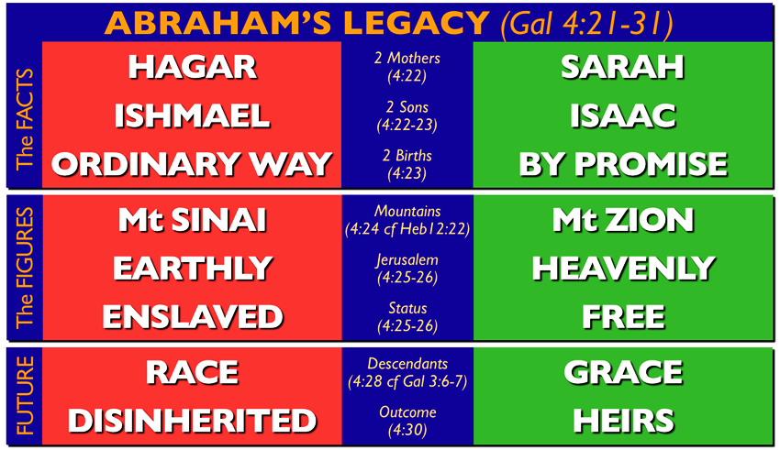
In this passage, Paul helps Galatian believers to understand who they are through comparison between Abraham’s two sons. He identifies the believers as the true children of Abraham, the children of the free woman, and the children of promise. He then helped the Galatian believers to resist those who would lead them into slavery under the law. May the Lord help us to live as the children of the free woman.

- Read verses 21-23. Why did Paul want the Galatians to be aware of what the law says? (21) By whom did Abraham have two sons? (22) How were the two sons different? (23)

1-1, Read verses 21-23.

Tell me, you who want to be under the law, are you not aware of what the law says? 22 For it is written that Abraham had two sons, one by the slave woman and the other by the free woman. 23 His son by the slave woman was born according to the flesh, but his son by the free woman was born as the result of a divine promise.

1-2, Why did Paul want the Galatians to be aware of what the law says? (21)

Tell me, you who want to be under the law, are you not aware of what the law says?

- The Galatians have expressed their desire to keep the regulations of the Mosaic law, they have not yet fully understood or accepted all the obligations of the law.
- Under the law, the focus is on my performance. Under the grace of God, the focus is on who Jesus is and what He has done.
- Paul now quoted from the Genesis. Paul could have meant by saying “Let’s have a Bible study. Open your Bibles to Genesis chapter 16.”
- Paul assumed that his readers knew the Bible. He explains his point from the story of Abraham, Hagar, and Sarah in Genesis 16:1-16.
- It is important that Paul refer back to the Scriptures again and again. Paul meant that they are not handling the Scriptures correctly.
- A true understanding of the Law of Moses should surely support the true gospel.

1-3, By whom did Abraham have two sons? (22)

For it is written that Abraham had two sons, one by the slave woman and the other by the free woman.

- The legalists who troubled the Galatians protested that they were children of Abraham, and therefore blessed. Paul will admit they are children of Abraham, but they forget that Abraham had two sons!
- Ishmael's mother, Hagar, was Abraham's slave(bond servant); Isaac's mother, Sarah, was Abraham's wife, a free woman.

1-4, How were the two sons different? (23)

His son by the slave woman was born according to the flesh, but his son by the free woman was born as the result of a divine promise.

- Since the social status of the mothers determined the social status of their sons, Ishmael was a slave and Isaac was free
- Ishmael's birth happened in the ordinary way, as a natural result of the sexual union of Abraham and Hagar "according to the flesh."
- Ishmael's birth was not caused by anything except the normal biological processes of conception and birth.
- Ishmael was Abraham’s son, but he was the son according to the flesh and unbelief and trying to make your own way before God.
- It often doesn’t look like it, but legalism is living according to the flesh. It denies God’s promise and tries to make(push) your own way to God through the law.
- This is living like a descendant of Abraham - but it is living like Ishmael.

- Isaac was born as the result of a promise. Abraham’s second son was named Isaac. He was born, miraculously, through Abraham’s wife Sarah (freewoman).
- Isaac was Abraham’s son, and he was the son of God’s promise and faith and God’s miracle for Abraham.
- Abraham believed God and His promise, and Isaac was born at God’s way and at God’s time.
- So his birth was done by the supernatural fulfillment of the power of God.
- If you have only experienced natural birth, you are by nature a slave. But if you have experienced supernatural birth by the fulfillment of God's promise in your life, you are the son of promise like Isaac and by God's grace you are set free.

2. Read verses 24-27. What do the two women represent? (24a) What covenant does Hagar represent? (24b-25) How was Sarah different from Hagar? (26) Why does the barren woman shout for joy? (27)

2-1. Read verses 24-27.
These things are being taken figuratively: The women represent two covenants. One covenant is from Mount Sinai and bears children who are to be slaves: This is Hagar. 25 Now Hagar stands for Mount Sinai in Arabia and corresponds to the present city of Jerusalem, because she is in slavery with her children. 26 But the Jerusalem that is above is free, and she is our mother. 27 For it is written:“Be glad, barren woman, you who never bore a child;shout for joy and cry aloud, you who were never in labor;because more are the children of the desolate woman than of her who has a husband.”

2-2. What do the two women represent? (24a)
These things are being taken figuratively: The women represent two covenants.
- The women represent two covenants: Covenant from Mount Sinai and covenant of promise
- In the Bible, a covenant is a “contract” that sets the rules for our relationship with God.
- Here Paul brings it right down to the issues confronting the Galatian Christians. The legalists wanted them to relate to God under one set of rules, and Paul wanted them to relate to God under the “rules” presented by the gospel.

2-3. What covenant does Hagar represent? (24b-25)
One covenant is from Mount Sinai and bears children who are to be slaves: This is Hagar. 25 Now Hagar stands for Mount Sinai in Arabia and corresponds to the present city of Jerusalem, because she is in slavery with her children.
- Hagar represent the covenant from Mount Sinai
- If Hagar represents the covenant from Mount Sinai, then the children of that covenant are destined to be slaves, since the children of Hagar, the slave woman, were destined to be slaves.
- “Mount Sinai Jerusalem" equation by drawing attention to the common characteristic of slavery of both the children of the Sinaitic covenant and the children of Jerusalem
- This covenant corresponds to Jerusalem which now is, that is, earthly Jerusalem which was the capital of religious Judaism.
- This was the way most Jewish people in Paul’s day tried to be right with God - by trusting in their ability to please God by keeping the law.
- Jerusalem was again the proud capital city for all the recipients of the covenant given at Mount Sinai.
- The goal of life in Jerusalem was to regulate all of life by the laws given at Mount Sinai. Mount Sinai and Jerusalem could be equated on the basis of this common characteristic of slavery.

2-4. How was Sarah different from Hagar? (26)
But the Jerusalem that is above is free, and she is our mother.

- The identification of the believers with the children of Sarah begins with a contrast between the present Jerusalem, whose children are in slavery, and the Jerusalem above, which is free
- In the heavenly new Jerusalem the people of God would experience the perfect rule of God in peace and harmony with him, one another and all of the new creation.
- All believers are already citizens and coheirs of the heavenly Jerusalem.
- Since they are already experiencing the Spirit of God, they are already enjoying the fulfillment of the promises of God. This means that they have already entered the heavenly Jerusalem
- There was no good reason for those who were experiencing the freedom of life as citizens of the heavenly Jerusalem to be bound by slavery to the law again, which was characteristic of the present, earthly Jerusalem.
- What a nonsense it is! It is like the difference between heaven and earth. It may reminds of Revelation 21.

Revelation 21:1-5 reads,

Then I saw “a new heaven and a new earth,” for the first heaven and the first earth had passed away, and there was no longer any sea. 2 I saw the Holy City, the new Jerusalem, coming down out of heaven from God, prepared as a bride beautifully dressed for her husband. 3 And I heard a loud voice from the throne saying, “Look! God’s dwelling place is now among the people, and he will dwell with them. They will be his people, and God himself will be with them and be their God. 4 ‘He will wipe every tear from their eyes. There will be no more death’ or mourning or crying or pain, for the old order of things has passed away.” 5 He who was seated on the throne said, “I am making everything new!” Then he said, “Write this down, for these words are trustworthy and true.”

2-5. Why does the barren woman shout for joy? (27)
For it is written:“Be glad, barren woman, you who never bore a child;shout for joy and cry aloud, you who were never in labor;because more are the children of the desolate woman than of her who has a husband.”

- Paul sees the fulfillment of the prophecy in the birth and growth of the church.
- The multiplication of the children of Sarah and the heavenly Jerusalem became a tangible reality for Paul as he witnessed the faith of Gentiles and their reception of the Spirit.
- As Paul saw this ancient promise of God fulfilled in his own mission to the Gentiles, he must have also fulfilled the commands of the prophecy.
- It was wonderful for him to see God fulfilling his word in this way as he preached the gospel to Gentiles. Amen!

3. Read verses 28-31. How did Paul call the believers? (28) What was happening to the Galatians like Isaac? (29) What does Scripture say about the slave woman’s son? (30) Whose children are we? (31)

3-1. Read verses 28-31.

Now you, brothers and sisters, like Isaac, are children of promise. 29 At that time the son born according to the flesh persecuted the son born by the power of the Spirit. It is the same now. 30 But what does Scripture say? “Get rid of the slave woman and her son, for the slave woman’s son will never share in the inheritance with the free woman’s son.” 31 Therefore, brothers and sisters, we are not children of the slave woman, but of the free woman.

3-2. How did Paul call the believers? (28)

Now you, brothers and sisters, like Isaac, are children of promise.

- Just as Isaac was born as the result of a promise, so the Gentile believers were born as a result of the fulfillment of God's promise to Abraham (3:8) and his promise through the prophet Isaiah (4:27). So the link between the Galatians and Isaac is established.
- As Christians, we don’t identify with Ishmael. We identify with Isaac, as children of a promise that was received by faith.

3-3. What was happening to the Galatians like Isaac? (29)

At that time the son born according to the flesh persecuted the son born by the power of the Spirit. It is the same now.

- The Jewish Christian teachers have been harassing them with their requirements and demands of the laws.
- That is exactly what happened in the story of Ishmael and Isaac: At that time the son born in the ordinary way persecuted the son born by the power of the Spirit. It is the same now (v. 29).
- One personal consequence of being like Isaac is being mocked and persecuted by “false brothers” like Ishmael. Paul experienced fierce opposition from “false brothers” who tried to destroy him and his work
- The legalists who are represented by Ishmael, have always persecuted true believers who are represented by Isaac.
- As we walk in the glory, in the freedom, in the miraculous power of this New Covenant, we should expect to be mistreated by those who don’t.

3-4. What does Scripture say about the slave woman’s son? (30)

But what does Scripture say? “Get rid of the slave woman and her son, for the slave woman’s son will never share in the inheritance with the free woman’s son.”

- Get rid of the slave woman and her son, for the slave woman’s son will never share in the inheritance with the free woman’s son
- To those who want to be under the law he gives a command that they should expel the law teachers.

- Hagar and Sarah could not live together in the same house (Genesis 21). We could argue all day long whose fault it was, but that isn’t the point. The point is that God told Abraham to send Hagar away.
- Sarah could live with Hagar and Ishmael until the son of promise was born. But once Isaac was born, then Hagar and Ishmael had to go.
- In the same way, a person could relate to the law one way before the promise of the gospel was made clear in Jesus Christ.
- But now that it has been made clear, there is nothing to do but to cast out the bondwoman and her son.

- Those who depend on the promises of God fulfilled in Christ will receive the inheritance. They are the true children of Abraham and Sarah
- Already all who have faith in Christ enjoy the inheritance: they have received their citizenship in the heavenly Jerusalem.
- The proof of that citizenship is the presence of the Spirit in their lives: they have been born by the power of the Spirit

3-5. Whose children are we? (31)

Therefore, brothers and sisters, we are not children of the slave woman, but of the free woman.

- We are not children of the slave woman, but of the free woman.
- The conclusion of the entire Hagar-Sarah allegory emphasizes once again the identification of believers in Christ.
- The children of the free woman, who were born by the power of the Spirit (v. 29) must learn to express their freedom by walking in the Spirit.
- They must not submit to slavery under the law or gratify the desires of the flesh.
- Identity is the basis of behavior: a clear understanding of who we are in Christ guides our conduct in the Spirit.

Conclusion

Those who live by the law are slaves as children of slave woman. We who believe the promise of God are true Abraham’s children, the children of freewoman and children of promise. We are born by the power of the Spirit. We have received the inheritance in Jesus. As children of the free woman, we must live by walking in the Spirit.

One word : Children of free woman

