NO OTHER GOSPEL

Galatians 1:1–10
Key Verse 8

“But even if we or an angel from heaven should preach a gospel other than the one we preached to you, let them be under God’s curse!”

Introduction

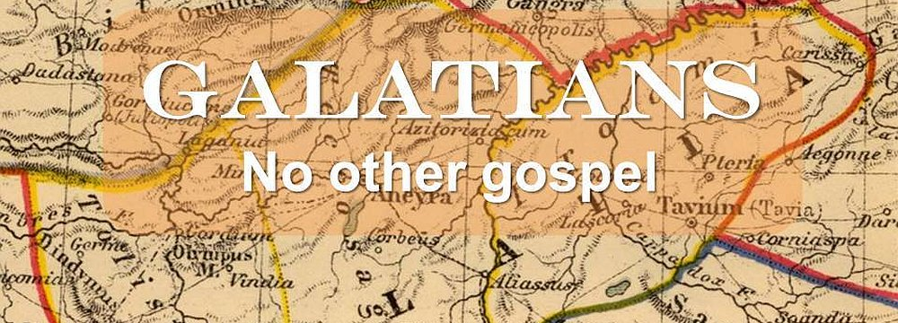

Paul wrote Galatians in A.D. 50 in order to help the Galatian believers stand firm in the gospel. The book of Galatians has been called "Declaration of Independence for Christian liberty." or “the Magna Charta of Christian Freedom.” Martin Luther said, “Galatians is my letter. I married Galatians...” At that time, the Galatian believers were tempted by legalistic people to submit to circumcision and keeping the laws of Moses, in addition to the gospel, for salvation. But through this letter, Paul addresses that Christians are justified by faith in Jesus alone, not by observing the law and that the gospel gives freedom from sin and legalism. But we should not misunderstand the word “freedom” here. These days, many people assume that freedom means doing whatever they want without any responsibility or consequence. This is not freedom. In fact this leads to slavery to sin. Let’s learn of true freedom and how to live by it as we study Galatians.

1. Read verses 1-5. How did Paul identify himself? (1) How did he greet the Galatian believers? (2-5) How did he present the gospel even in his greeting? (1, 4)

1-1, Read verses 1-5.

Paul, an apostle—sent not from men nor by a man, but by Jesus Christ and God the Father, who raised him from the dead— 2 and all the brothers and sisters[a] with me.
3 Grace and peace to you from God our Father and the Lord Jesus Christ, 4 who gave himself for our sins to rescue us from the present evil age, according to the will of our God and Father, 5 to whom be glory for ever and ever. Amen.

1-2, How did Paul identify himself? (1)

Paul, an apostle—sent not from men nor by a man, but by Jesus Christ and God the Father, who raised him from the dead—

- As we know well, Paul was not one of 12 apostles. The word “apostle” means one who is sent by the Christ for a special mission.
- Paul met the risen Jesus personally, who sent him to the Gentiles to preach the gospel. This was his mission. (Ac 9:15)
- Since then Paul had no doubt in his heart that he was an apostle.
- Paul also emphasized that his apostleship came not from human beings, but from Jesus Christ.
- He also believed that those who are met by Jesus Christ personally received grace and apostleship as well.

Romans 1:5 reads,

“Through him we received grace and apostleship to call all the Gentiles to the obedience that comes from faith for his name’s sake.”

- Likewise, all Christians have received grace and apostleship through Jesus Christ. In each generation, Jesus calls his people and sends them out to preach the gospel.

1-3, How did he greet the Galatian believers? (2-5)
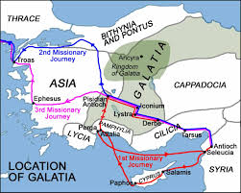
and all the brothers and sisters with me,
To the churches in Galatia:
3 Grace and peace to you from God our Father and the Lord Jesus Christ, 4 who gave himself for our sins to rescue us from the present evil age, according to the will of our God and Father, 5 to whom be glory for ever and ever. Amen.

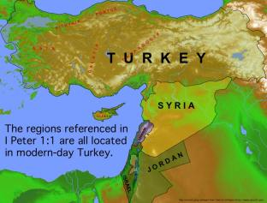
- Galatia was not just one city, but rather an area that we now know as Turkey.
- The cities to which Paul ministered in Galatia included Antioch of Pisidia, Iconium, Lystra, and Derbe.
- In Acts 13 and 14, Paul taught about the gospel through Jesus Christ. (13:39, 14:3)

- "Grace is always first, peace always second. This is due to the fact that grace is the source of peace. Without grace there is and can be no peace.
- Paul used the word ‘grace’ 100 times in his writings. Paul was truly the apostle of grace although he was known as a servant of passion.
- Praise Jesus who changed him from a legalistic persecutor to a servant of grace!

who gave himself for our sins to rescue us from the present evil age

- Jesus came to rescue us from this present evil age. The particular word for evil denotes someone who is not content in being corrupt themselves; they also must corrupt others, and draw them into their same destruction.
- The idea behind the word ‘deliver’ is not deliverance from the presence of something, but deliverance from the power of something.
- We will not be delivered from the presence of this evil age until we go to be with Jesus. But we can be experience deliverance from the power of this present evil age right now.

1-4, How did he present the gospel even in his greeting? (1, 4)

Paul, an apostle—sent not from men nor by a man, but by Jesus Christ and God the Father, who raised him from the dead --- who gave himself for our sins to rescue us from the present evil age, according to the will of our God and Father, 5 to whom be glory for ever and ever. Amen.

- The Apostle Paul included the gospel even in His greeting. His greeting here is very unique compared with his other letters. This came from his shepherd heart over his flocks in Galatia to help them from the beginning of this letter.
- It may remind us of 1 Corinthians 15:1-4.

Now, brothers and sisters, I want to remind you of the gospel I preached to you, which you received and on which you have taken your stand. 2 By this gospel you are saved, if you hold firmly to the word I preached to you. Otherwise, you have believed in vain.
3 For what I received I passed on to you as of first importance: that Christ died for our sins according to the Scriptures, 4 that he was buried, that he was raised on the third day according to the Scriptures,

- Paul earnestly wanted the believers in Galatia to understand the gospel deeply and live it out more fully.
- Many Christians think that the gospel is for unbelievers and assume that they already know the gospel.
- But Christians are those who live by the gospel from the beginning to the end. After meeting Christ Jesus, Paul lived by the gospel until the end of his life.

Philippians 3:10, 11 reads,

“I want to know Christ—yes, to know the power of his resurrection and participation in his sufferings, becoming like him in his death, and so, somehow, attaining to the resurrection from the dead.”

1 Corinthians 2:2 reads,

“For I resolved to know nothing while I was with you except Jesus Christ and him crucified.”

1 Corinthians 1:18-25 reads,

For the message of the cross is foolishness to those who are perishing, but to us who are being saved it is the power of God. 19 For it is written: “I will destroy the wisdom of the wise; the intelligence of the intelligent I will frustrate.” 20 Where is the wise person? Where is the teacher of the law? Where is the philosopher of this age? Has not God made foolish the wisdom of the world? 21 For since in the wisdom of God the world through its wisdom did not know him, God was pleased through the foolishness of what was preached to save those who believe. 22 Jews demand signs and Greeks look for wisdom, 23 but we preach Christ crucified: a stumbling block to Jews and foolishness to Gentiles, 24 but to those whom God has called, both Jews and Greeks, Christ the power of God and the wisdom of God. 25 For the foolishness of God is wiser than human wisdom, and the weakness of God is stronger than human strength.

- The gospel gave Paul true freedom, strength, joy and hope. He had a strong desire to know the gospel deeper and deeper.
- Do we live out the gospel daily and fully? The gospel is not just the ABC’s of Christian faith and life, it is A-Z.
- In the midst of many struggles and problems in life, what we need most is to understand the gospel more deeply and to live it out fully.

- Jesus offered his body as a perfect sacrifice on the cross to rescue us from our sins.
- Sin is serious because it demands condemnation. But Jesus gave himself, his life blood to rescue us from condemnation. Through the sacrifice of Jesus, the price for our sins was paid in full and we could receive the grace of forgiveness.

2. Read verses 6-7. What happened to some believers in Galatia? (6) How did this happen? (7)

2-1, Read verses 6-7.

I am astonished that you are so quickly deserting the one who called you to live in the grace of Christ and are turning to a different gospel— 7 which is really no gospel at all. Evidently some people are throwing you into confusion and are trying to pervert the gospel of Christ.

2-2, What happened to some believers in Galatia? (6)

I am astonished that you are so quickly deserting the one who called you to live in the grace of Christ and are turning to a different gospel—

- After a short greeting, he now cut to the chase in tackling their issue. It’s as though he was saying, “We need to talk now!”
- They were turning away from a Person (from Him who called you) as they turned to a false idea (to a different gospel). To turn away from the true gospel is always to turn away from the Person of Jesus Christ.
- The phrase, “the one who called you to live in the grace of Christ” sheds light on living by the gospel.
- Living by the gospel means living by the grace of Christ. We are forgiven daily by the grace of Christ. We are called daily by his grace.
- We grow spiritually in his grace. In his grace, we have hope in heaven. The gospel gives us forgiveness, joy, thanksgiving to God, hope and love. Let us restore the true and pure gospel in us and live daily in his grace, having joy, thanksgiving, hope and love.

2-3, How did this happen? (7)

which is really no gospel at all. Evidently some people are throwing you into confusion and are trying to pervert the gospel of Christ.

- During his first missionary journey, Paul preached the gospel in the region of Galatia that Christ died for our sins and God raised him from the dead giving us a living hope in the kingdom of God.
- In Acts 15:1, some time later some men (false teachers) from the church in Judea confused them. Just as old habits die hard, they fell hard for the judaizers who told them that unless they kept the law of Moses, observed the covenant of circumcision, they could not be saved.
- This is what Paul called “a different gospel.” In their confusion, some Galatian believers abandoned the gospel of grace by faith and turned to the false teaching which was not really the gospel.
- Satan is always working to undermine the faith of new believers. He will often introduce ideas that seem to be from God’s Word, and lead new believers into serious error.
- There are many seasoned believers who have fallen for some “new” doctrine that is introduced by a charismatic personality who claims to have a new, more enlightened understanding of God’s Word than anyone else has yet attained.
- This “new” knowledge then becomes far more important to these Christians than their original understanding of the wonderful gospel of Jesus Christ in its simplicity.
- In fact, there is nothing new under the sun. Satan just recycles his deceptions under different titles, knowing how gullible we are and how easily attracted we are to the same old things as long as it’s wrapped in shiny new paper.

3. Read verses 8-10. What strong warning did Paul give about those trying to pervert the gospel of Christ? (8–9) What can we learn from Paul as a servant of Christ? (10)

3-1, Read verses 8-10.

But even if we or an angel from heaven should preach a gospel other than the one we preached to you, let them be under God’s curse! 9 As we have already said, so now I say again: If anybody is preaching to you a gospel other than what you accepted, let them be under God’s curse! 10 Am I now trying to win the approval of human beings, or of God? Or am I trying to please people? If I were still trying to please people, I would not be a servant of Christ.

3-2, What strong warning did Paul give about those trying to pervert the gospel of Christ? (8–9)

But even if we or an angel from heaven should preach a gospel other than the one we preached to you, let them be under God’s curse! 9 As we have already said, so now I say again: If anybody is preaching to you a gospel other than what you accepted, let them be under God’s curse!

- Two times, he said, “let them be under God’s curse!” Paul used strong language against the false teachers to help believers remain steadfast in the true gospel.
- Gospel in Greek is “euangelion” meaning “good news,” or “good message.”
- What was the good news or message Paul delivered to them? It was that God loved the world so much that he sent his one and only Son Jesus to save sinners just like us.
- Jesus died for our sins (4a) and God raised Jesus from the dead (1a). When we come to Jesus with repentance and believe in him we are saved from our sin and also from death.
- We cannot earn our salvation. Our salvation is sorely secured by God’s grace and by our faith. This is the true and pure gospel.

3-3, What can we learn from Paul as a servant of Christ? (10)

Am I now trying to win the approval of human beings, or of God? Or am I trying to please people? If I were still trying to please people, I would not be a servant of Christ.

- By this gospel, Paul was saved from sin and condemnation. Before accepting the gospel, he was greatly burdened by his sins, even though others thought that he was a promising young man. His heart was so dark because contrary to his desire to do good, he actually ended up doing evil (Ro 7:19-20).
- He realized that with his own effort he could not save himself. So he cried, “What a wretched man I am! Who will rescue me from this body that is subject to death?” But he really thanked God who delivered him through Jesus Christ (Ro 7:24-25).
- In this way, the gospel made him free from the law and condemnation. The gospel made him joyful. The gospel made him very thankful to God and Christ.
- The gospel made him humble before God. The gospel filled him with love and inspired him to love God with all his heart.
- Paul lived out the gospel to the end of his life. He understood the gospel more deeply and lived by the gospel.
- He preached the gospel everywhere he went willingly, even risking his life, because he really wanted others to know this good news of the gospel.

Conclusion

The authentic gospel message might still be offensive to our human nature. First, the gospel offends our pride. It tells us we need a savior, and that we cannot save ourselves. It gives no credit to us at all for our salvation; it is all the work of Jesus for us. Second, the gospel offends our wisdom. It saves us by something many consider foolish - God becoming man and dying a humiliating, disgraceful death on our behalf. Third, the gospel offends our knowledge. It tells us to believe something which goes against scientific knowledge and personal experience - that a dead man, Jesus Christ, rose from the dead in a glorious new body that would never die again. So throughout Church history, the true and pure gospel has been challenged numerous times. Even today, many false teachings try to pervert the gospel by adding something to the gospel. It is easy for us to dismiss the gospel unintentionally in the course of struggling with life’s problems and challenges and try to live according to our own set of rules and standards. Then we become slaves of them again, full of guilt and dissatisfaction. Instead of coming to Christ and living by the gospel, we end up living with a dark, fatalistic, and grumpy heart. The gospel is not only for unbelievers but also for all Christians. Christians must live daily by the gospel.

One word: The Gospel!

