Put in All

Luke 21:1-4
Key Verse 4

“All these people gave their gifts out of their wealth; but she out of her poverty put in all she had to live on.”

Introduction

In Luke’s gospel we see several beautiful women: Elizabeth, who after conceiving John the Baptist confessed, “The Lord has done this for me. In these days he has shown his favour and taken away my disgrace among the people” (1:25); Mary, who gave up her own plan of marriage to receive God’s favour and said, “I am the Lord’s servant” (1:38); Anna who became a widow after 7 years of marriage but served God praying in the temple day and night and looking forward to the redemption of Jerusalem (2:37), a nameless woman, who poured out her perfume on Jesus’ feet because of his grace of forgiveness of her sins (7:38), another Mary, who chose to sit at Jesus’ feet listen him amid many works to do (10:39); and this nameless widow, who gave all to the Lord out of her poverty. All these women were the ones who set apart Christ as Lord in their hearts. In today’s passage, Jesus saw people doing offering at the temple and praised a poor widow as the one who offered more than anyone else. Through Jesus’ teaching we can learn what kind of offering can please God and be considered as a valuable one.

- Read verses 1-2. Why do you think Jesus took notice of those making an offering in the temple treasury? What did Jesus see as the rich made their offering? (1, Mk 12:41) What did the poor widow put in? (2) What was the value of two copper coins (Mk 12:42)

1-1. Read verses 1-2.

As Jesus looked up, he saw the rich putting their gifts into the temple treasury. 2 He also saw a poor widow put in two very small copper coins

1-2. Why do you think Jesus took notice of those making an offering in the temple treasury?

- As a background, according to history, wealthy diaspora Jews were sending generous gifts to finance the temple's reconstruction, which was begun by King Herod.

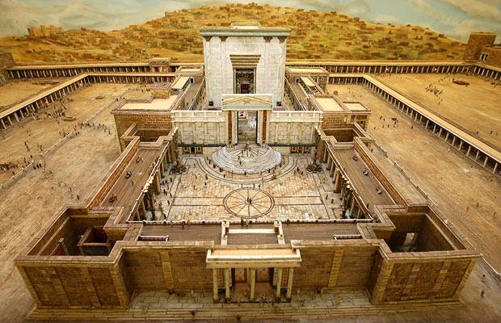
- Herod, a Gentile, wanted to ingratiate himself with the Jews, and also built a memorial to his achievements.

- Herod also contributed to the temple by building a magnificent golden vine with grape clusters as tall as a man.

- Jewish leaders overlooked the inherent danger of compromise with Herod and willingly participated.
- The construction of the temple took more than 80 years, from 19 B.C. to 63 A.D. The number of workers reached 10,000.
- This great national building project seemed to have captured the minds and hearts of the people of Israel.
- Generous donors might have been recognized by putting their names and offering amounts on commemorative plaques and posting them in a prominent place.
- They may have listed first class givers ($10,000 or more), second class givers ($5,000 or more), etc.
- To many, these generous gifts were impressive. But Jesus saw more than that.

Deuteronomy 16:16b-17 reads,

“No man should appear before the Lord empty-handed: Each of you must bring a gift in proportion to the way the Lord your God has blessed you.”

- Jesus’ keen observation. He observes the things that are done on earth.
- The eyes of the Lord are in every place (Prov 15:3) Nothing is too small for God to miss or ignore it.

1-3. What did Jesus see as the rich made their offering? (1, Mk 12:41)

Jesus sat down opposite the place where the offerings were put and watched the crowd putting their money into the temple treasury. Many rich people threw in large amounts. - Mk 12:41

- They offered large amounts of money.
- The amount of money was big enough to be noticeable.
- People might recognize their big offering and the rich people could be proud of their big offering.

1-4. What did the poor widow put in? (2)

He also saw a poor widow put in two very small copper coins

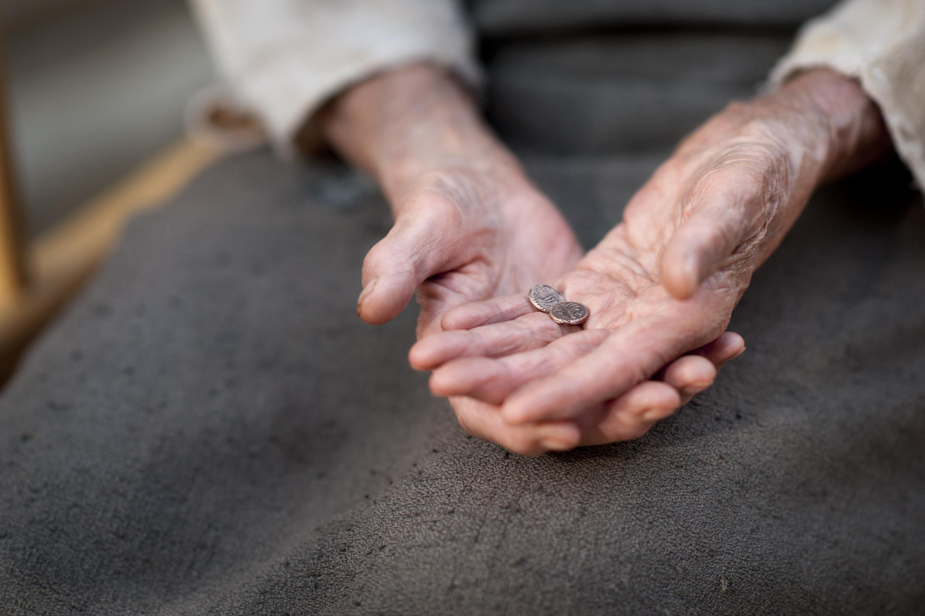

- Even though the widow’s offering was so small, Jesus still recognized it.
- Other people might not have paid any attention to widow’s small offering but Jesus did.

1-5. What was the value of two copper coins (Mk 12:42)

But a poor widow came and put in two very small copper coins, worth only a few cents.

- The two very small copper coins were two ‘Lepton’s.
- One Lepton was 1/128 worth of one Denarius, which was the wage of one days work.
- These days minimum wage is about $10 per hour and people can make at least $80 through one day work. Her offering was less than 20 cents.
- People might ignore her offering and laugh at her because her offering was so small.
- Her offering seemed to be nothing comparing with those of the rich people’s.

- In brief let us think about how the widow could give all she had.
- A widow has no one to depend on, especially if she does not have a grown-up child. She must have come to the temple in order to seek God’s help for her future.
- How desperate could she have been for she had only two copper coins to live on?
- According to the Bible, however, the widow had to offer something as she came to God.
- If she had to offer in proportion, she need to cut one of her copper coins into five pieces and offer one of the pieces(10%), but that was not a practical option.
- Maybe at that moment she remembered the story of a widow who offered all she had when Elijah the prophet asked the widow to make a meal for him first.
1 King 17: 7-16 reads,
Some time later the brook dried up because there had been no rain in the land. 8 Then the word of the Lord came to him: 9 “Go at once to Zarephath in the region of Sidon and stay there. I have directed a widow there to supply you with food.” 10 So he went to Zarephath. When he came to the town gate, a widow was there gathering sticks. He called to her and asked, “Would you bring me a little water in a jar so I may have a drink?” 11 As she was going to get it, he called, “And bring me, please, a piece of bread.” 12 “As surely as the Lord your God lives,” she replied, “I don’t have any bread—only a handful of flour in a jar and a little olive oil in a jug. I am gathering a few sticks to take home and make a meal for myself and my son, that we may eat it—and die.” 13 Elijah said to her, “Don’t be afraid. Go home and do as you have said. But first make a small loaf of bread for me from what you have and bring it to me, and then make something for yourself and your son. 14 For this is what the Lord, the God of Israel, says: ‘The jar of flour will not be used up and the jug of oil will not run dry until the day the Lord sends rain on the land.’” 15 She went away and did as Elijah had told her. So there was food every day for Elijah and for the woman and her family. 16 For the jar of flour was not used up and the jug of oil did not run dry, in keeping with the word of the Lord spoken by Elijah.

- Though she planned to use the last bit of money she had for her and her son and die, she first offered it to a servant of God just as she was instructed. Then, she received the blessing of God’s provision for the rest of her life.
- She wholeheartedly offered all she had, two copper coins, seeking God’s help by faith.

2. Read verses 3-4. What did Jesus say about the poor widow’s offering? (3) Why did Jesus value her humble offering more than all the others? (4) What does Jesus recognize about our offering?

2-1. Read verses 3-4.

“Truly I tell you,” he said, “this poor widow has put in more than all the others. 4 All these people gave their gifts out of their wealth; but she out of her poverty put in all she had to live on.”

2-2. What did Jesus say about the poor widow’s offering? (3)

“this poor widow has put in more than all the others”

- The amount of the widow’s offering was far less than the rich people’s offering, but Jesus considered the widow’s offering to be more than the rich people’s offering.
- Jesus’ measure is very different from the measure of man. Jesus values each one’s offering with a different measure.
- Man sees the visible amount of money that people offer, but Jesus sees some other things too.
- Something that looks small to us could be a very valuable thing in Jesus’ sight.
- The value of our offering would not be considered or valued just based on the amount of money, but would be valued according to what God values.
- Jesus taught a proportion analysis, not the total amount but the proportion of giving.
- We need to see based on God’s perspective and consider God’s measure about our offering.

2-3. Why did Jesus value her humble offering more than all the others? (4)

“All these people gave their gifts out of their wealth; but she out of her poverty put in all she had to live on.”

- Jesus valued the proportion of wealth that people offered more than the actual amount of money offered.
- The rich offered their offering out of their wealth. It was not a big portion of what they had. It might have been a large amount but still it was just a small part of their wealth. Their offering would not affect their remaining assets significantly.
- Their offering didn’t affect their financial situation that much. They still had a huge amount leftover even after making a significant offering.
- But the widow offered out of her poverty putting in all she had to live on.
- The widow’s offering was an 100% portion of her wealth. Even though her offering was so small, it was the entire amount of her wealth.
- Jesus saw the value of people’s offerings both among the rich and also the poor widow.
- To someone who was rich, a huge amount of money could be very small to them but to someone with just one dollar, their offering could be a very large amount like the poor widow.
- Her offering was a significant amount for her. She put in all the money that she had to live on. Her offering would affect her practical life significantly.
- Again the widow gave all she had out of her poverty, but others brought a fraction of their wealth.
- If a person like Donald Trump donates a million dollars to a poorly rated veteran organization, most of us would say, “Wow.”
- But Jesus takes notice of our heart and the proportion of our offering among our belongings.
- There is a saying, "Give until it hurts; then give a little more."

2-4. What does Jesus recognize about our offering?

- Jesus looks at how much value of our offering has compared with what we have.
- Our offering could be small but if that offering is valuable and precious to us, the offering could be considered a large offering to God.
- Knowing how Jesus considers our offering, we are comforted, even if what we offer is small.
- Our offering depends on our love and faith towards God.
- Offering to God is a matter of our heart and faith. God sees our love and faith that when we make any offering to him.
- In fact our offering shows who God is to us and what we believe about him.

3. Why do you think the widow put in all she had to live on? What does her exemplary offering teach us about how to please God?

3-1. Why do you think the widow put in all she had to live on?

- It was because of her deep love for God and faith in him. Her love and faith was expressed through her offering.
- She loved and valued God even until she offered all she had to live on.
- She loved God even more than her life.
- She might not be able to eat for the day because of her offering but she might be happy because of her offering.
- She was the one who served God first and foremost.
- She relied on God for her life instead of relying on money.

3-2. What does her exemplary offering teach us about how to please God?

- God is pleased with the offering that is offered with sincere love for him and in faith.
- To offer in a way that can please God, we have to check how much we love him and how much we trust him.
- The offering that pleases God never loses God’s reward. The woman was highly honored and recognized as the one who offered the most.

- Also, God does not need anything but our hearts. God has everything, so why then does he ask for our offering?

Psalms 51:16-17 reads,

“You do not delight in sacrifice, or I would bring it; you do not take pleasure in burnt offerings. The sacrifice of God are a broken spirit; a broken and contrite heart, O God, you will not despise.”

- What God truly wants from us is not our money but our broken and contrite heart towards God.
- God wants us to repent of our pride and humble ourselves though we may bring large amount of offering to God.
- He wants us to bring our thanksgiving for what he has done.
- May God bless us to bring our offering with repentance and a thankful heart to him. Amen.

Conclusion

The way God measures our offering is different from how people do. He sees the true value of our offering. Jesus does not see just the amount, but how much we sacrifice. Jesus measures the willingness and generosity of our hearts. If rich people give large offerings without feeling the pain of sacrifice, it is not noteworthy. But the widow's comparatively small offering moved Jesus' heart. It was because she sacrificed everything. She showed that she loved God more than money. Her offering was an act of worship. Moreover, it was all she had to live on. This shows that she did not calculate about her future; she trusted God with her life. Furthermore, she did not compare herself with those who gave more, and feel inferior. She gave to God as an act of personal faith. Finally, she did not become discouraged because religious leaders were corrupted, and so stop giving. She gave without reservation as a matter of faithfulness to God. May God help us to offer pleasing offerings to God through a deep love and faith in Him.

One word: Put it all

