Blessed is the King

Luke 19:28-40
Key Verse: 19:38

“Blessed is the king who comes in the name of the Lord!” “Peace in heaven and glory in the highest!”

Introduction

The main theme of Jesus’ teaching up to this point was the kingdom of God. According to 2 Samuel 5:6-7, King David marched to Jerusalem which was impregnable and captured the city from the Jebusites and called it the City of David. David ruled all Israel and Judah 33 years in Jerusalem. Then God promised David that his kingdom will endure forever and his throne will be established through his descendant. (2 Sam 7:16) Now Jesus, identified as the Son of David by a blind beggar in Luke 18:35, enters Jerusalem the capital city to establish the eternal kingdom of God as God promised to David in the OT. Jesus is ready to face his final spiritual battle to liberate Jerusalem from the rule of Satan. Since Jesus resolutely set out for Jerusalem in Luke 9:51, Jesus has been moving toward Jerusalem. Finally, Jesus arrives in Jerusalem and people joyfully shouted and praised him. But people hoped that Jesus would be a political king. The Jewish leaders were disturbed by this. Jesus came as King of heavenly peace and glory instead. King Jesus promises peace and deliverance to all who accept his lordship. Let’s accept Jesus as Lord in our hearts through this passage.

1. Read verses 28-34. What did Jesus command his two disciples when he approached Jerusalem? (28-31) What does “the Lord needs it” tell us about Jesus? How were they to deal with the situation? (32-34) What can we learn from their obedience?

1-1, Read verses 28-34.

After Jesus had said this, he went on ahead, going up to Jerusalem. 29 As he approached Bethphage and Bethany at the hill called the Mount of Olives, he sent two of his disciples, saying to them, 30 “Go to the village ahead of you, and as you enter it, you will find a colt tied there, which no one has ever ridden. Untie it and bring it here. 31 If anyone asks you, ‘Why are you untying it?’ say, ‘The Lord needs it.’”
32 Those who were sent ahead went and found it just as he had told them. 33 As they were untying the colt, its owners asked them, “Why are you untying the colt?”
34 They replied, “The Lord needs it.”

1-2, What did Jesus command his two disciples when he approached Jerusalem?
(28-31)

After Jesus had said this, he went on ahead, going up to Jerusalem. 29 As he approached Bethphage and Bethany at the hill called the Mount of Olives, he sent two of his disciples, saying to them, 30 “Go to the village ahead of you, and as you enter it, you will find a colt tied there, which no one has ever ridden. Untie it and bring it here. 31 If anyone asks you, ‘Why are you untying it?’ say, ‘The Lord needs it.’”
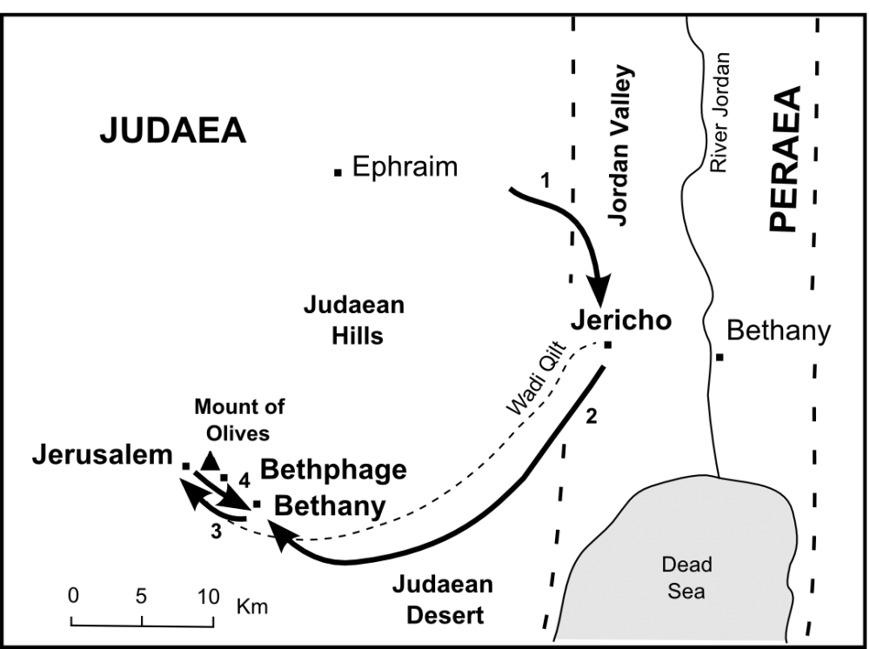
- After carefully correcting His followers as to the true nature of His kingdom and His mission, Jesus went steadfastly towards Jerusalem.
- Luke wrote repeatedly that Jesus went on ahead, going up to Jerusalem.
- Although Jesus was a wanted man from jealous religious leaders, he courageously advanced to Jerusalem.

John 11:55-57 reads,

“When it was almost time for the Jewish Passover, many went up from the country to Jerusalem for their ceremonial cleansing before the Passover. 56 They kept looking for Jesus, and as they stood in the temple courts they asked one another, “What do you think? Isn’t he coming to the festival at all?” 57 But the chief priests and the Pharisees had given orders that anyone who found out where Jesus was should report it so that they might arrest him.”

he sent two of his disciples, saying to them, 30 “Go to the village ahead of you, and as you enter it, you will find a colt tied there, which no one has ever ridden. Untie it and bring it here.

- Jesus needed a colt to ride into Jerusalem in accordance with the prophecy about Him.
- Jesus came to fulfill the will of God.

Zechariah 9:9 reads,

“Rejoice greatly, O Daughter of Zion! Shout, Daughter of Jerusalem! See, your king comes to you, righteous and having salvation, gentle and riding on a donkey, on a colt, the foal of a donkey.”

1-3, What does “the Lord needs it” tell us about Jesus?

- First of all Jesus reveals His full knowledge here: (1) the colt’s location, (2) it’s tied-up condition, (3) it’s ‘unridden’ history, and (4) how to get it.
- Jesus knows everything in advance. We don’t know what will happen tomorrow. So many people live in fear. But Jesus knows our future and will take care of us when we trust and obey his word.
- The Hebrew name in Old Testament for God is YHWH. Due to no vowel in it, its substitute name is adonai or Lord. The Greek word here for Lord is Kyrios.
- Jesus is God. Kyrios, the Lord, also means “master,” “ruler” and “owner.” Jesus is the Master and Owner of all things.

John 1:3 reads,

“Through him all things were made; without him nothing was made that has been made.”

Colossians 1:16 reads,

“For in him all things were created: things in heaven and on earth, visible and invisible, whether thrones or powers or rulers or authorities; all things have been created through him and for him.”

- If Jesus is truly Lord, then our lives and our possessions are not merely our own. They belong to the Lord.
- Disciples of Jesus are those who accept the lordship of Christ over their lives and possessions.
- The two disciples of Jesus who went and retrieved the colt simply obeyed Jesus without complaints or questions.
- When they simply obeyed Jesus rather than their own idea or common sense, they experienced success in their mission.

1-4, How were they to deal with the situation? (32-34)

Those who were sent ahead went and found it just as he had told them. 33 As they were untying the colt, its owners asked them, “Why are you untying the colt?” 34 They replied, “The Lord needs it.”

1-5, What can we learn from their obedience?

- A question we need to ask ourselves continually is this: “What is directing my life, actions, and words? Is it my own ideas and opinions, or is it the word of God in the Bible?”
- In other words, am I living right now as my own master, or is Jesus the Lord of my heart, my life and the things I have?
- When we remain in Jesus' word, the Holy Spirit is our Counselor and Guide.
- When Jesus is Lord in our hearts, we can obey his commands and can give freely of ourselves and our possessions without calculation or complaint.
- According to Romans 6, we became the instruments of righteousness thanks to Jesus’ death and resurrection.

Romans 6:8-14 reads,
“Now if we died with Christ, we believe that we will also live with him. 9 For we know that since Christ was raised from the dead, he cannot die again; death no longer has mastery over him. 10 The death he died, he died to sin once for all; but the life he lives, he lives to God. 11 In the same way, count yourselves dead to sin but alive to God in Christ Jesus. 12 Therefore do not let sin reign in your mortal body so that you obey its evil desires. 13 Do not offer any part of yourself to sin as an instrument of wickedness, but rather offer yourselves to God as those who have been brought from death to life; and offer every part of yourself to him as an instrument of righteousness. 14 For sin shall no longer be your master, because you are not under the law, but under grace.”
- The Lord needs our life to make disciples of all nations. When we accept Jesus’ Lordship for His own concern, we are blessed to fulfill His original creation purpose in Genesis 1:28.
- So denying ourselves and accepting His Lordship over our life is the secret to being fruitful.
- May the Lord raise up many disciples among us like the two obedient disciples in the passage.

- Also through this passage, we know Jesus’ wisdom to raise up His disciples.
- God has a master plan for reaching and transforming a lost world. Jesus came with the purpose of reclaiming the world with the Gospel.
- He chose twelve ordinary men and gave them three years of training through association with Him, observing, obeying, and sending them out equipped with the Word, prayer and the Holy Spirit to reproduce disciples. That is the Lord's program, and it is reaching the world.
- Jesus could have made a play for the masses and sought to usher in the kingdom by popular acclaim. Yet He discouraged the crowd, downplayed Himself publicly, revealing Himself to His disciples and those who believed instead of the religious leaders.
- In this way His plan tested the few men He had chosen. The Lord knew that the quality of discipleship and not quantity of disciples was more important.
- Before the masses could be reached, taught, and ministered to, leaders had to be raised.
- One man cannot carry the load of the whole world- first a foundation must be laid. Jesus concentrated on His disciples for a good reason. Disciples instead of mere converts was His very goal.
- That was why Jesus must have trained His two!

2. Read verses 35-38. How did Jesus enter Jerusalem? (35, 36) How did the whole crowd of disciples welcome Jesus and praise God? (37-38, Zech 9:9-10) What was the purpose of his entry into Jerusalem? (Lk 18:31-33) What does their praise show about Jesus and his kingdom?

2-1, Read verses 35-38.

They brought it to Jesus, threw their cloaks on the colt and put Jesus on it. 36 As he went along, people spread their cloaks on the road.
37 When he came near the place where the road goes down the Mount of Olives, the whole crowd of disciples began joyfully to praise God in loud voices for all the miracles they had seen: 38 “Blessed is the king who comes in the name of the Lord!” “Peace in heaven and glory in the highest!”

2-2, How did Jesus enter Jerusalem? (35, 36)

They brought it to Jesus, threw their cloaks on the colt and put Jesus on it. 36 As he went along, people spread their cloaks on the road.

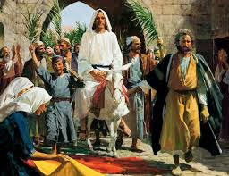
- The idea of a victorious, conquering king entering a city was well known in that time.
- Typically, a victorious king came into a city escorted by the citizens of his kingdom and his army.
- As he entered, songs were sung in praise and acclamation of the conqueror and he came with symbols of his victory and authority.
- Finally he came into the city's prominent temple and made a sacrificial offering to honor the gods and associate himself with them.

- Jesus entered Jerusalem with a relatively humble and motley escort and singing. The only symbols of His power were a humble donkey and palm branches.
- Upon entering the city, He did not offer sacrifices but He challenged the religious status quo and cleansed the temple.

2-3, How did the whole crowd of disciples welcome Jesus and praise God? (37-38, Zech 9:9-10)

37 When he came near the place where the road goes down the Mount of Olives, the whole crowd of disciples began joyfully to praise God in loud voices for all the miracles they had seen: 38 “Blessed is the king who comes in the name of the Lord!” “Peace in heaven and glory in the highest!”

Rejoice greatly, Daughter Zion! Shout, Daughter Jerusalem! See, your king comes to you, righteous and victorious, lowly and riding on a donkey, on a colt, the foal of a donkey. 10 I will take away the chariots from Ephraim and the warhorses from Jerusalem, and the battle bow will be broken. He will proclaim peace to the nations. His rule will extend from sea to sea and from the River to the ends of the earth. - Zechariah 9:9-10

- The whole crowd of disciples praised God because of all the miracles they had seen.
- Jesus commanded evil spirits to be driven out of many people and He healed many who were sick. Jesus healed a man with leprosy, a paralyzed man, a man with a shriveled hand, and a centurion’s dying servant.
- A widow’s dead son was being carried out for burial. Jesus stopped the funeral procession and said to the dead man, “Young man, I say to you, get up!” He sat up and began to talk.
- Jesus calmed the stormy sea. He drove a legion of demons out of man into a herd of pigs. Jesus cured a bleeding woman, then raised Jairus’ dead daughter back to life again, saying to her, “My child, get up!”
- Jesus fed over 5000 men with 5 loaves of bread and 2 fish. Jesus healed a man’s son of a self-destructive spirit. Jesus healed a hunchbacked woman.
- Jesus healed 10 men of leprosy, though only 1 came back to thank him. Jesus gave a blind beggar his sight and so on.
- This is why the people praised God joyfully. They acknowledged Jesus as God’s chosen and anointed King saying: “Blessed is the king who comes in the name of the Lord!”

Psalm 118:26 reads,

“Blessed is he who comes in the name of the Lord.
From the house of the Lord we bless you.”

- This was a psalm to welcome a conquering king. They praised and thanked God for Jesus the King, who came in the name of the Lord.
- Jesus was a conqueror but not in a worldly sense. He had no army and no soldiers.
- But he defeated demons, sicknesses, and death. These were powers that no earthly king could possess.

2-4, What was the purpose of his entry into Jerusalem? (Lk 18:31-33)

Jesus took the Twelve aside and told them, “We are going up to Jerusalem, and everything that is written by the prophets about the Son of Man will be fulfilled. 32 He will be delivered over to the Gentiles. They will mock him, insult him and spit on him; 33 they will flog him and kill him. On the third day he will rise again.”

- Because of the sins of all people, there was grief in heaven--a divide between the holy God and sinful men.
- Mark 11:9 added the word, “Hosanna,” which means “God saves.”
- In order to save us from our sins and set us free from Satan, Jesus would become the Lamb of God.
- Through the death of Jesus Christ on the cross for our sins, there is now peace between God and humankind.

Colossians 1:20 reads,

“...and through him to reconcile to himself all things, whether things on earth or things in heaven, by making peace through his blood, shed on the cross.”

- By his death and resurrection, Jesus destroyed him who holds the power of death, that is, the devil.
- Jesus defeated God’s enemy and ours and there is peace in heaven. Those who accept Jesus as King, share in his victory over sin and Satan.

Luke 2:14 reads,

“Glory to God in the highest, and on earth peace to men on whom his favor rests.”

- Jesus’ life and ministry and obedience to God’s will is glory to God in the highest.
- Jesus’ whole life purpose and goal was to bring honor and glory to God Most High, the Father in heaven. Praise Jesus, our Lord!

2-5, What does their praise show about Jesus and his kingdom?
- Again Jesus was entering into Jerusalem to fulfill the prophecy to deliver people from Satan’s captivity.
- Jesus entered into Jerusalem not for a military battle but for a spiritual battle. He did not ride on a white horse like a Roman military general.
- But He rode on a colt, showing Himself as the gentle and humble King, though He is the Creator God in His eternal kingdom.

3. Read verses 39-40. Why did the Pharisees tell Jesus to rebuke his disciples? (39) How did he respond? (40) What does it reveal about Jesus?

3-1, Read verses 39-40.

39 Some of the Pharisees in the crowd said to Jesus, “Teacher, rebuke your disciples!” 40 “I tell you,” he replied, “if they keep quiet, the stones will cry out.”

3-2, Why did the Pharisees tell Jesus to rebuke his disciples? (39)

39 Some of the Pharisees in the crowd said to Jesus, “Teacher, rebuke your disciples!”
- They were offended or worried by the disciples’ messianic confession of Jesus and so sought to silence them as quickly as possible.
- They regarded such praise as inappropriate. They did not recognize Jesus as God’s King.

3-3, How did he respond? (40)

40 “I tell you,” he replied, “if they keep quiet, the stones will cry out.”

- Jesus refused to rebuke his disciples.
- Jesus’ coming as God’s King demanded a response. If the disciples were quiet, the stones would cry out.
- The stones would cry out “Hosanna! Praise the Lord!” Jesus says that if they ceased to cry out, then creation would cry out in testimony to him. What irony!
- Creation is aware of Jesus’ coming as the Savior, but the leadership of the nation is not.
- Thus, the disciples’ shout of praise was appropriate and legitimate. Jesus is God’s King.
- Many political leaders in America work hard to silence Christians not to praise Jesus in schools and in public places. They allow millions of unborn babies to be killed legally. What irony.
- American forefathers came to this country to praise Jesus, risking their lives. Now their descendants try to stop us from praising Jesus.
- We should not be silenced by this world. Before the stones cry out to the Lord, we should cry out to praise Jesus and welcome him as the one who comes in the name of the Lord.
- Praising the Lord is our response to the coming King.
- The voices of this world cannot silence our praise to the King Jesus.

Psalm 96:11-13 reads,
“Let the heavens rejoice, let the earth be glad; let the sea resound, and all that is in it. 12 Let the fields be jubilant, and everything in them; let all the trees of the forest sing for joy. 13 Let all creation rejoice before the Lord, for he comes, he comes to judge the earth. He will judge the world in righteousness and the peoples in his faithfulness.”

Psalm 148:7-14 reads,

“Praise the Lord from the earth, you great sea creatures and all ocean depths, 8 lightning and hail, snow and clouds, stormy winds that do his bidding, 9 you mountains and all hills, fruit trees and all cedars, 10 wild animals and all cattle, small creatures and flying birds, 11 kings of the earth and all nations, you princes and all rulers on earth, 12 young men and women, old men and children. 13 Let them praise the name of the Lord, for his name alone is exalted; his splendor is above the earth and the heavens. 14 And he has raised up for his people a horn, the praise of all his faithful servants, of Israel, the people close to his heart. Praise the Lord.”

3-4, What does it reveal about Jesus?

- Jesus is our Creator and the very Owner of our life.

Zechariah 14:9 reads,

“The Lord will be king over the whole earth. On that day there will be one Lord, and his name the only name.”

Zechariah 14:5-6 also reads,

“You will flee by my mountain valley, for it will extend to Azel. You will flee as you fled from the earthquake in the days of Uzziah king of Judah. Then the Lord my God will come, and all the holy ones with him.”

- Judah under the rule of a king Uzziah, was very prosperous and satisfied.
- But spiritually she became complacent and back sliden.
- God sent a powerful earthquake that resulted in a landslide at Azel.
- Jesus might have gone on the way up to Jerusalem and had to go through this dusty land. As He traveled, He must have been reminded of this historical fact.
- When people don’t choose life in and through Jesus who is King of kings, they will perish at God’s due time.

Amos 5:6 reads,

“Seek the Lord and live, or he will sweep through the tribes of Joseph like a fire;
it will devour them, and Bethel will have no one to quench it.”

- May the Lord help us to seek and praise Him with all our hearts. Amen,

Conclusion

Today we studied Jesus’ triumphal entry into Jerusalem. His entry was a triumph because he would defeat our enemy Satan and set us free from his terror. He would wash away all our sins and open the door of the kingdom of God through his death and resurrection. Jesus would become our Savior King. He showed his humbleness by riding on a colt. May God bless us to welcome Jesus with respect and accept his Lordship over our lives. May we praise and worship him with our hearts. Amen.

One word: Blessed is the King!

