How Often I Have Longed to Gather Your Children

Luke 13:31-35
Key verse 34

“Jerusalem, Jerusalem, you who kill the prophets and stone those sent to you, how often I have longed to gather your children together, as a hen gathers her chicks under her wings, and you were not willing.”

Introduction

In today’s passage Jesus shows us how to live in view of God’s salvation purpose. When we encounter difficulty, it is easy to lose our focus to keep serving God’s mission. May the Lord help us to fix our eyes on Jesus who is the perfecter of our faith. May the Lord richly bless us through today’s passage and continue to be faithful in serving campus mission with all our hearts.

1. Read verses 31-32a. What warning did the Pharisees give to Jesus? (31) Why might Herod have wanted to kill him? What did Jesus call Herod and what can we learn from Jesus? (32a)

1-1, Read verses 31-32a.

At that time some Pharisees came to Jesus and said to him, “Leave this place and go somewhere else. Herod wants to kill you.” 32 He replied, “Go tell that fox,

1-2, What warning did the Pharisees give to Jesus? (31)

“Leave this place and go somewhere else. Herod wants to kill you.”

- We don’t know why some Pharisees came to Jesus.
- This shows that not all the Pharisees opposed Jesus. it seems that some wanted to protect Him from the plotting of Herod.

1-3, Why might Herod have wanted to kill him?

- Here Herod was known as Herod Antipater (Greek: Ἡρῴδης Ἀντίπατρος, Hērǭdēs Antipatros; born before 20 BC – died after 39 AD), known by the nickname Antipas. He was a 1st-century ruler of Galilee and Perea, who bore the title of tetrarch ("ruler of a quarter").

Luke 3:1-3 reads,
“In the fifteenth year of the reign of Tiberius Caesar—when Pontius Pilate was governor of Judea, Herod tetrarch of Galilee, his brother Philip tetrarch of Iturea and Traconitis, and Lysanias tetrarch of Abilene— 2 during the high-priesthood of Annas and Caiaphas, the word of God came to John son of Zechariah in the wilderness. 3 He went into all the country around the Jordan, preaching a baptism of repentance for the forgiveness of sins.”

Jesus was on the way to Jerusalem. The flow and context of the passage indicates that he was probably passing on the land of Perea.

- The Division of Herod's Kingdom: Territory under Herod Archelaus, from 6 Iudaea Province Territory under Herod Antipas Territory under Herod Philip II Salome I (cities of Jabneh, Azotas, Phaesalis) Roman province of Syria Autonomous cities (Decapolis) - From Wikipedia
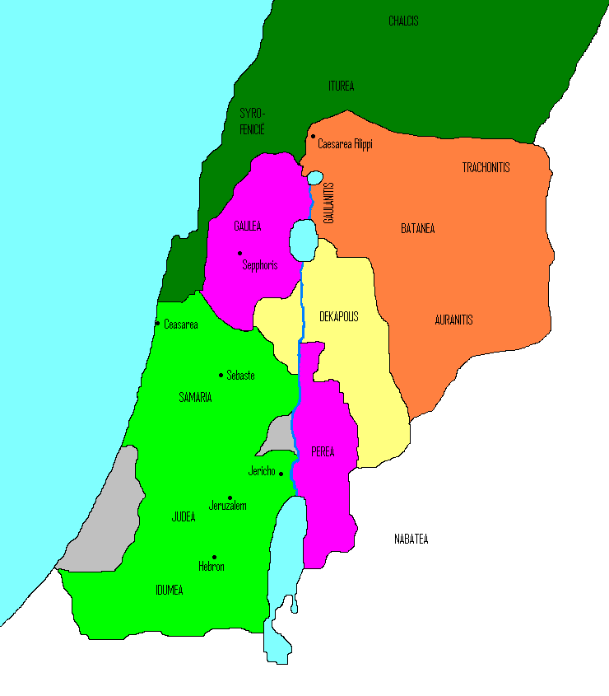
- Antipas faced more immediate problems in his own tetrarchy after John the Baptist – according to the Gospel of Luke began a ministry of preaching and baptism by the Jordan River, which marked the western edge of Antipas' territory of Perea.

- John rebuked the tetrarch's adulterous marriage for it was incestuous, as Herodias was also Antipas' niece, while Josephus says that John's public influence made Antipas fearful of rebellion. John was imprisoned in Machaerus and executed.
- According to Matthew and Mark, Herod was reluctant to order John's death but was compelled by Herodias' daughter, to whom he had promised any reward she chose as a result of her dancing for guests at his birthday banquet.

- Among those baptized by John was Jesus of Nazareth, who began his own ministry in Galilee – causing Antipas, according to Matthew and Mark, to fear that the Baptizer had been raised from the dead.
- Luke alone among the Gospels states that a group of Pharisees warned Jesus that Antipas was plotting his death, whereupon Jesus denounced the tetrarch as a "fox" and declared that he, Jesus, would not fall victim to such a plot because "it cannot be that a prophet should perish away from Jerusalem".
- Luke also credits the tetrarch with a role in Jesus' trial. According to Luke, Pilate, on learning that Jesus was a Galilean and therefore under Herod's jurisdiction, sent him to Antipas, who was also in Jerusalem at the time.
- Initially, Antipas was pleased to see Jesus, hoping to see him perform a miracle, but when Jesus remained silent in the face of questioning Antipas mocked him and sent him back to Pilate. Luke says that these events improved relations between Pilate and Herod despite their earlier enmity.

1-4, What did Jesus call Herod and what can we learn from Jesus? (32a)

- Jesus called him “that fox.”
- This is the Herod that Jesus called “that fox.”
- The fox is both crafty and inferior in its position. The fox is an insignificant wild animal, in contrast to the lion.
- He lacks real power and dignity, using cunning deceit to achieve his aims.
- Indeed like a fox, Herod gained his position shrewdly and used cunning deceit to achieve his goals in many aspects including his re-marriage.

John 2:24 reads,

“But Jesus would not entrust himself to them, for he knew all people. 25 He did not need any testimony about mankind, for he knew what was in each person.”

- Jesus knew that the intentions of Herod’s heart were to destroy the work of God – by killing Him.

Song of Songs 2:15 reads,

“Catch for us the foxes, the little foxes that ruin the vineyards, our vineyards that are in bloom.”

- This scripture reveals that the intent of the foxes is to destroy the vines. Also in John 15:1, Jesus says that He is the true vine and the Father is the Gardener.

2. Read verses 32b-33. What did Jesus teach about his mission? What can we learn from Jesus’ words, “today and tomorrow,” “I will reach my goal,” “In any case,” “I must press on,” and “for surely”? Why was Jesus so determined? (33b)

2-1, Read verses 32b-33.

‘I will keep on driving out demons and healing people today and tomorrow, and on the third day I will reach my goal.’ 33 In any case, I must press on today and tomorrow and the next day—for surely no prophet can die outside Jerusalem!

2-2, What did Jesus teach about his mission?

- When Jesus taught the people in Nazareth, he proclaimed that his mission was based on what is written in the book of Isaiah.

Luke 4:16-21 reads,

“He went to Nazareth, where he had been brought up, and on the Sabbath day he went into the synagogue, as was his custom. He stood up to read, 17 and the scroll of the prophet Isaiah was handed to him. Unrolling it, he found the place where it is written: 18 “The Spirit of the Lord is on me, because he has anointed me to proclaim good news to the poor. He has sent me to proclaim freedom for the prisoners and recovery of sight for the blind, to set the oppressed free, 19 to proclaim the year of the Lord’s favor.” 20 Then he rolled up the scroll, gave it back to the attendant and sat down. The eyes of everyone in the synagogue were fastened on him. 21 He began by saying to them, “Today this scripture is fulfilled in your hearing.”

Isaiah 61:1 reads,

“The Spirit of the Sovereign LORD is on me, because the LORD has anointed me to proclaim good news to the poor. He has sent me to bind up the brokenhearted, to proclaim freedom for the captives and release from darkness for the prisoners,”

- Also he helped the messengers sent by John the baptist with the same message.

Luke 7:22 reads,

“So he replied to the messengers, "Go back and report to John what you have seen and heard: The blind receive sight, the lame walk, those who have leprosy are cleansed, the deaf hear, the dead are raised, and the good news is proclaimed to the poor.”

‘I will keep on driving out demons and healing people today and tomorrow, and on the third day I will reach my goal.’ 33 In any case, I must press on today and tomorrow and the next day—for surely no prophet can die outside Jerusalem!

John 6:38 reads,

“For I have come down from heaven not to do my will but to do the will of him who sent me.”

John 4:34 reads,

"My food," said Jesus, "is to do the will of him who sent me and to finish his work.

2-3, What can we learn from Jesus’ words, “today and tomorrow,” “I will reach my goal,” “In any case,” “I must press on,” and “for surely”?

‘I will keep on driving out demons and healing people today and tomorrow, and on the third day I will reach my goal.’ 33 In any case, I must press on today and tomorrow and the next day—for surely no prophet can die outside Jerusalem!

- Jesus is the same yesterday, today, and tomorrow. (Hebrew 13:8)
- Jesus never changed his way of life according to his own, rather was faithful to the end to fulfill God’s will.

‘I will keep on driving out demons and healing people today and tomorrow, and on the third day I will reach my goal.’ 33 In any case, I must press on today and tomorrow and the next day—for surely no prophet can die outside Jerusalem!

- Regarding this phrase, KJV(King James Version) shows, “I shall be perfected.”
- Jesus shared with his disciples repeatedly about what would happen to him.

Matthews 16:21 reads,
“From that time on Jesus began to explain to his disciples that he must go to Jerusalem and suffer many things at the hands of the elders, the chief priests and the teachers of the law, and that he must be killed and on the third day be raised to life.”

- Jesus knew that he would reach the goal on the third day - resurrection would be His.
- I shall then have accomplished the purpose for which I came into the world.
Hebrew 10:7-10 reads,
“Then I said, ‘Here I am—it is written about me in the scroll—I have come to do your will, my God.’ 8 First he said, “Sacrifices and offerings, burnt offerings and sin offerings you did not desire, nor were you pleased with them”—though they were offered in accordance with the law. 9 Then he said, “Here I am, I have come to do your will.” He sets aside the first to establish the second. 10 And by that will, we have been made holy through the sacrifice of the body of Jesus Christ once for all.”

‘I will keep on driving out demons and healing people today and tomorrow, and on the third day I will reach my goal.’ 33 In any case, I must press on today and tomorrow and the next day—for surely no prophet can die outside Jerusalem!

- There was no deviation in Jesus. Nothing will deter Jesus from God’s call for world salvation.
- Jesus was sent by God on a mission. He was headed to Jerusalem to die, and the threat of an earthly ruler like Herod would not stop him.
- He regarded his mission more than his own life.
- God’s servants must follow Jesus’ example like apostle Paul.

Acts 20:22-24 reads,
“And now, compelled by the Spirit, I am going to Jerusalem, not knowing what will happen to me there. 23 I only know that in every city the Holy Spirit warns me that prison and hardships are facing me. 24 However, I consider my life worth nothing to me; my only aim is to finish the race and complete the task the Lord Jesus has given me—the task of testifying to the good news of God’s grace.

- Do you regard your mission more precious than your life?
- There are many who deviated due to many excuses. Anytime and in anyplace we should be like Jesus and follow His example.
- May the Lord help each of us to be faithful to the point of death in following Jesus. Amen.

2-4, Why was Jesus so determined? (33b)

“for surely no prophet can die outside Jerusalem!”

- Again Jesus knew that he must die in Jerusalem as the Lamb of God; it was God's will. Jesus would finish this mission and rise again
- Jesus did not move according to Herod’s threat. Jesus was sure that he would not die at random or by the crafty scheme of Herod.
- Jesus knew that according to God’s kingdom purpose, he would die in Jerusalem.
- Jesus trusted his Father God, the Sovereign Ruler, and his almighty power. God’s kingdom was advancing by God’s power and nothing could stop it.
- All that mattered to Jesus was to follow God’s leading. As he did so, he had no fear of worldly rulers or their kingdom.

Matthews 16:21 reads,

“From that time on Jesus began to explain to his disciples that he must go to Jerusalem and suffer many things at the hands of the elders, the chief priests and the teachers of the law, and that he must be killed and on the third day be raised to life.”

3. Read verses 34-35. Why was Jesus lamenting over Jerusalem? What was his longing and hope? (34) What can we learn from Jesus? Describe the spiritual condition of the people. (35a) What would happen to them? (35b)

3-1, Read verses 34-35.

“Jerusalem, Jerusalem, you who kill the prophets and stone those sent to you, how often I have longed to gather your children together, as a hen gathers her chicks under her wings, and you were not willing. 35 Look, your house is left to you desolate. I tell you, you will not see me again until you say, ‘Blessed is he who comes in the name of the Lord.’”

3-2, Why was Jesus lamenting over Jerusalem?

“Jerusalem, Jerusalem, you who kill the prophets and stone those sent to you,”

- It was a great irony that the holy city Jerusalem became the city most hostile to God. It was there that the prophets had been killed. It was there that the Messiah would be rejected and crucified as a criminal.
- The consequence would be the terrible destruction of that city and severe punishment of its residents.
- Jesus spoke with special affection, using repetition of the name ‘Jerusalem’ for emphasis. When God repeats a name, it’s to display deep emotion as in Luke 10:41(Martha, Martha) or Acts 9:4(Saul, Saul).
- Jesus still pleaded with the city of Jerusalem to repent and to turn from the destruction that would come upon it.

3-3, What was his longing and hope? (34)

“I have longed to gather your children together, as a hen gathers her chicks under her wings,”

- Here Jesus expressed his shepherd broken heart for them like a mother hen trying to protect and gather her chicks.
- Do I share Jesus’ broken shepherd heart for young people in America who live without the love of God? May God teach us the heart of Jesus’ love.

3-4, What can we learn from Jesus?

- Jesus expressed God’s broken heart for his people Israel. Jesus is not willing that his beloved people perish. When they are unwilling he weeps over them.
- As we advance in the kingdom we too see those who miss the chance to enter. It is the time we can learn Jesus’ broken heart for the lost and weep for them.

3-5, Describe the spiritual condition of the people. (35a)

your house is left to you desolate.

- These words Seem to predict the coming destruction of Jerusalem by the Roman army in A.D. 70.

3-6, What would happen to them? (35b)

“I tell you, you will not see me again until you say, ‘Blessed is he who comes in the name of the Lord.”

- Here Jesus revealed the condition of the world surrounding His Second Coming.
- When Jesus comes again, the Jewish people will welcome Him as the Messiah saying, Blessed is He who comes in the name of the Lord!

- It will take a great deal to bring Israel to that point, but God will do it. It is promised that Israel will welcome Jesus back even as the Apostle Paul said in Romans 11.

Romans 11:25-32 reads,

“I do not want you to be ignorant of this mystery, brothers and sisters, so that you may not be conceited: Israel has experienced a hardening in part until the full number of the Gentiles has come in,26 and in this way all Israel will be saved. As it is written: “The deliverer will come from Zion; he will turn godlessness away from Jacob. 27 And this is my covenant with them when I take away their sins.” 28 As far as the gospel is concerned, they are enemies for your sake; but as far as election is concerned, they are loved on account of the patriarchs, 29 for God’s gifts and his call are irrevocable. 30 Just as you who were at one time disobedient to God have now received mercy as a result of their disobedience,31 so they too have now become disobedient in order that they too may now receive mercy as a result of God’s mercy to you. 32 For God has bound everyone over to disobedience so that he may have mercy on them all.”

Conclusion

May the Lord help each of us to follow Jesus’ example in fulfilling the will of God in this ever-changing generation. Like our Lord Jesus Christ, may we confess that in any situation we would press on in serving God today, tomorrow, and the next day until God’s will is completed. May the Lord help us to have the same compassionate heart of our Lord Jesus. Amen.

One word: Today and Tomorrow!

